**MINISTRY OF EDUCATION AND SCIENCE OF THE REPUBLIC OF**

**KAZAKHSTAN**

**“Kazakh-British Technical University” JSC**

**School of Information Technology and Engineering**

**Speciality 6B06102 “Computer Systems and Software”**

**ADMITTED TO DEFENCE**

Dean of SITE,

___________ A. Imanbayev “___”___________ 2024

**EXPLANATORY NOTE**

**TO GRADUATION PROJECT (work)**

**Theme:** “Enhancing Sustainable Waste Management: Design, Implementation, and Evaluation of a Smart Waste Sorting Assistant Application”

**Author/s:**

____________ Yuhyeon Choi

“__” ____________ 2024

**Major:**

6B06102 – “Computer Systems and Software”

**Supervisor:**

Professor, PhD

____________ Ilyas Muhammad

“__” ____________ 2024

**Norms Compliance Monitor**

Senior Lecturer

____________ A. Ziro

“__” ____________ 2024

**MINISTRY OF EDUCATION AND SCIENCE OF THE REPUBLIC OF**

**KAZAKHSTAN**

**“Kazakh-British Technical University” JSC**

**School of Information Technology and Engineering**

**Speciality 6B06102 “Computer Systems and Software”**

**ADMITTED TO DEFENCE**

Dean of SITE,

___________ A. Imanbayev

“___”___________ 2024

**DIPLOMA PROJECT ASSIGNMENT**

Student/s: Yuhyeon Choi

Project title: “Enhancing Sustainable Waste Management: Design, Implementation, and Evaluation of a Smart Waste Sorting Assistant Application.”

Approved by the KBTU order: № _______dated “___” ___________

Submission deadline: ____________________

List of issues addressed in the diploma project or its brief content:

1. Background
2. Research
3. Project description
4. Methodologies: Technologies and features of this project
5. Development
6. Marketing research
7. Future directions & plans

Consultations regarding the project with indication of respective reasons:

|  |  |  |  |
| --- | --- | --- | --- |
| Section | Consultant  (academic degree, title) | Timeline | Signature |
| Section 1 | Ilyas Muhammad, Professor, PhD |  |  |
| Section 2 | Ilyas Muhammad, Professor, PhD |  |  |

**DIPLOMA PROJECT WORK SCHEDULE**

|  |  |  |
| --- | --- | --- |
| Sections, issues addressed | Submission deadline | Notes |
| Section 1 |  |  |
| Section 2 |  |  |

Dean of SITE _____________________ A. Imanbayev

(signature)

Project Supervisor _____________________ Ilyas Muhammad

(signature)

Author _____________________ Yuhyeon Choi

(signature)

**Project sheet**

|  |  |  |  |  |  |
| --- | --- | --- | --- | --- | --- |
| № | Format | Designation | Denomination | Quantity | Note |
| 1 | A4 |  | Explanatory note | 1 | 67  pages |
| 2 | .pdf |  | Electronic copy of  the diploma project | 1 |  |
| 2 | .pdf |  | Presentation File | 1 |  |

**ABSTRACT**

This thesis presents a detailed design and analysis of a smart programing application, called 'Rejoycle'. It is a waste sorting assistant application (App) aimed at contributing to the field of sustainable waste management through technological innovation. The core of this research revolves around the application's technical framework, leveraging advanced tools like Core ML for image recognition, the OpenAI API for user guidance on recycling practices, and Firebase for efficient database management.

The development process of ‘Rejoycle’ App is carefully examined, focusing on the technical challenges encountered and the solutions adopted to address them. This study also analyzes the Application's user interface and features, designed to enhance user engagement and promote environmentally responsible behavior. An essential component of the thesis is a thorough market analysis, identifying the App's position within the competitive arena of similar technologies.

The thesis concludes with a modest outlook on future enhancements and expansions for 'Rejoycle,' acknowledging the continuous evolution of technology in this field and the App's role in it.

This work aims to contribute to the growing knowledge of environmental technology applications, emphasizing the importance of sustainable practices and innovative solutions in waste management.

**АННОТАЦИЯ**

В этой диссертации представлен подробный проект и анализ интеллектуального программного приложения под названием Rejoycle. Это приложение-помощник по сортировке мусора (App), призванное внести вклад в область устойчивого управления отходами посредством технологических инноваций. В основе этого исследования лежит техническая структура приложения, использующая передовые инструменты, такие как Core ML для распознавания изображений, API OpenAI для руководства пользователя по методам переработки и Firebase для эффективного управления базами данных.

Процесс разработки приложения Rejoycle тщательно изучается с упором на возникающие технические проблемы и решения, принятые для их решения. В этом исследовании также анализируется пользовательский интерфейс и функции Приложения, призванные повысить вовлеченность пользователей и способствовать экологически ответственному поведению. Важным компонентом диссертации является тщательный анализ рынка, определяющий позицию приложения на конкурентной арене аналогичных технологий.

Диссертация завершается скромным обзором будущих усовершенствований и расширений Rejoycle, признавая непрерывную эволюцию технологий в этой области и роль приложения в ней.

Целью этой работы является содействие растущим знаниям в области применения экологических технологий, подчеркивая важность устойчивых методов и инновационных решений в области управления отходами.

**АҢДАТПА**

Бұл дипломдық жұмыс «Rejoycle» деп аталатын смарт бағдарламалау қосымшасының егжей-тегжейлі дизайны мен талдауын ұсынады. Бұл технологиялық инновациялар арқылы қалдықтарды тұрақты басқару саласына үлес қосуға бағытталған қалдықтарды сұрыптау көмекшісі қосымшасы (Қолданба). Бұл зерттеудің өзегі кескінді тану үшін Core ML, қайта өңдеу тәжірибесі бойынша пайдаланушы нұсқаулығы үшін OpenAI API және дерекқорды тиімді басқару үшін Firebase сияқты кеңейтілген құралдарды пайдалана отырып, қолданбаның техникалық негізіне айналады.

'Rejoycle' қолданбасын әзірлеу процесі кездескен техникалық қиындықтарға және оларды шешу үшін қабылданған шешімдерге назар аудара отырып, мұқият зерттеледі. Бұл зерттеу сонымен қатар пайдаланушының қатысуын жақсартуға және қоршаған ортаға жауапты мінез-құлықты ынталандыруға арналған Қолданбаның пайдаланушы интерфейсі мен мүмкіндіктерін талдайды. Диссертацияның маңызды құрамдас бөлігі ұқсас технологиялардың бәсекелестік аренасында Қолданбаның позициясын анықтайтын мұқият нарықты талдау болып табылады.

Диссертация осы саладағы технологияның үздіксіз эволюциясын және ондағы Қолданбаның рөлін мойындай отырып, «Rejoycle» үшін болашақ жақсартулар мен кеңейтулерге қарапайым көзқараспен аяқталады.

Бұл жұмыс қалдықтарды басқарудағы тұрақты тәжірибелер мен инновациялық шешімдердің маңыздылығын атап көрсете отырып, қоршаған ортаны қорғау технологиясын қолдану туралы өсіп келе жатқан білімге үлес қосуға бағытталған.

**CONTENT**

**INTRODUCTION** 9

1. **BACKGROUND** 10
   1. Application Development Purpose 11
2. **RESEARCH** 13
   1. Global
   2. South Korea 15
   3. Research Objectives 17
3. **PROJECT DESCRIPTION** 18
   1. Project Overview
   2. Selection of Features 20
4. **METHODOLOGIES: Technologies and Features of this project** 22
   1. Technical Details
      1. Swift & Xcode
      2. UIKit 23
      3. OOP (Objected Oriented Program) 24
      4. MVC model (Model-View-Controller) 25
      5. Firebase 26
      6. Core ML 27
      7. OpenAI API 28
5. **DEVELOPMENT** 29
   1. Development Process
      1. View & Model & Controller 31
      2. Firebase 42
      3. CoreML 46
      4. OpenAI API 47
   2. Challenges and Solutions 48
6. **MARKETING RESEARCH** 49
   1. Market Strategy
   2. Competitive Analysis 50
7. **FUTURE DIRECTIONS & PLANS** 51
   1. Enhancing Technical Capabilities
   2. User Experience and Interface Improvements 52
   3. Long-Term Vision and Goals 53

**CONCLUSION** 54

**REFERENCES** 55

**APPENDICES** 56

**INTRODUCTION**

This diploma work aimed to describe the development of an application named 'Rejoycle', which aims to decrease the problem of global waste. Through this work, we want readers to know more deeply and in detail about the developed App. This will cover in great detail the development background, the supporting evidence, the technologies and processes used, and what impact this App will have on the world in the future.

The application, named ‘Rejoycle’, will be handy for those who want to solve the global waste problem by recycling waste and turning it into something useful. First, it has the ability to distinguish items to be recycled and serves as a social network that allows users to share their creative ideas actively. It periodically helps users check posts posted by other users and encourage them to support their activities through the 'Like' button.

To implement all these features, the code is written using Swift programming language. Swift boasts an intuitive and efficient structure and helps you engage in more creative activities through uncomplicated libraries. In addition, the structure was designed to take advantage of the characteristics of the Objected Oriented Program. Abstraction, inheritance, and polymorphism increase code reusability and ease of maintenance. Machine Learning was used to distinguish between items. Using Core ML provided by Apple, we created and applied a model to determine desired items. After identifying the most essential items, we used Open AI to creatively answer questions about how to reuse the items. In particular, Open AI has been of great help in dealing with vast amounts of data. Lastly, Firebase system is used to provide a community to users. This is a program that manages databases and users supplied by Google and offers excellent performance and security.

Our report will describe the project in the following process.

1. Background - This section will explain the motivation and need of creating this App.
2. Research - This section will closely examine and explain the data and surveys that serve as background evidence explained above.
3. Project description – This section will explain the overall project and the functions and user interface of the application.
4. Methodologies - All functions used within the app will be explained in detail with examples to explain why each function is used and how it is used.
5. Development - This part will cover the development process in detail. There are three main processes in development: app conception, design, and implementation.
6. Marketing research - Research will cover about competitiveness and discussion what position the various features of the app have in the market and how it will survive against competing apps.
7. Conclusion and future plan - This section will conclude the work done in this project and some limitations of the developed app. Finally, it will give some future directions on improving the app’s features and functions. It also discusses how to develop and register this app on the App Store for greater accessibility and usage.
8. **BACKGROUND**

This section will give about what led the project to develop the application and why chose Swift (Xcode) to create it. Before explaining the background, it is necessary to understand the application. Basically, an application refers to a program that helps users perform necessary tasks on a computer or other devices. All computer programs use to perform various tasks can be called 'Applications.' In other words, it is the most important and closely active thing in human life today. So, what device is best to create an app that works on? The following table can explain it. The following table compares desktop and smartphone sales in 2023.

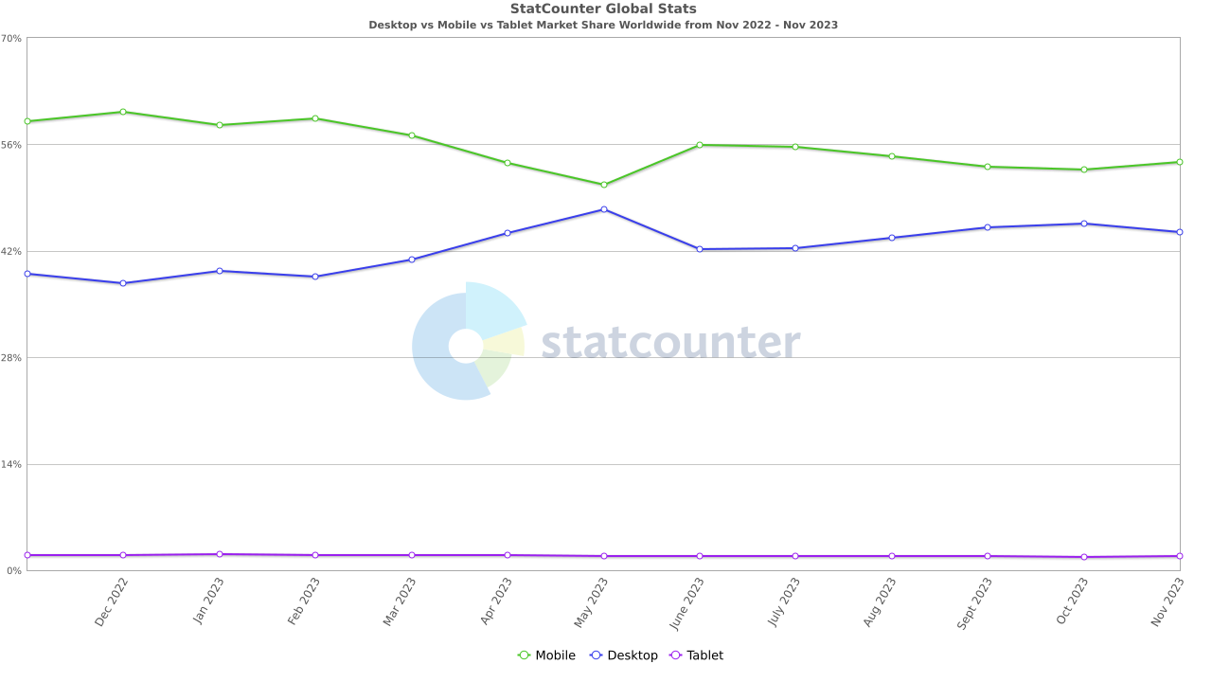

Table 1. Desktop vs Mobile vs Tablet Market Share Worldwide [1]

According to Table 1, smartphone sales will be high from the second half of 2022 to the second half of 2023. In other words, creating a smartphone app is more likely to secure many users.

After choosing a platform, it is necessary to choose the programming language needed to create the App. Swift is a language provided by Apple. Since its first release in 2014, Swift is a modern programming language mainly used for developing iOS-based applications and is often adopted as an alternative to Objective-C. Of course, various programming languages, such as Flutter, currently support a wide range of operating systems, but Swift is widely chosen because of its stability and convenience. Convenience and safety are the most essential factors in creative activities. In conclusion, Swift was the best programming language for the project.

* 1. **Application Development Purpose**

As explained earlier, applications are closely related to our daily lives and can have the most significant impact.

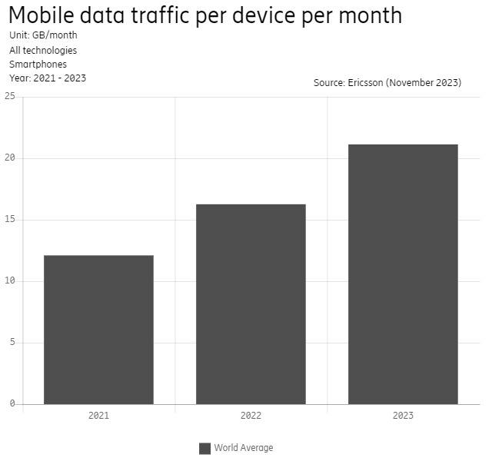

Table 2. Mobile data traffic per device per month [2]

According to Table 2, mobile data traffic is increasing by close to 30% every year. Since increased traffic can also be seen as an increase in user usage, this is sufficient evidence for the closeness of the application. Therefore, it is profitable to create applications that can be used on mobile devices. So, what kind of application should build? The following four rules were used to determine the topic of the application.

1. Convenient
2. Conciseness
3. Expandability
4. Beneficial

First, let's talk about convenience. Why should mobile applications be convenient? The answer is straightforward. This is because smartphones (mobiles) were developed for human convenience. Of course, if an application is used on such a smartphone, it must also be convenient. So, what does it mean for an application to be suitable? This is the definition of application convenience: "What you want is where you want it." In other words, the user interface of the application creates convenience.

Next, simplicity is essential for mobile applications. This simplicity means simplicity of function. If the application's functions give users a complex feeling in various ways, it is clear that the user utilization rate will gradually decrease. If the developer has something he wants from the user through the app, he should create the app as simply as possible, focusing on that point.

Third is Expandability. Expansion allows users to have more and more experiences with a given function. At first, it was a simple function, but as time passed and various information was exchanged, it allowed users to have an expanded experience different from before. The important thing is to provide an extended experience with few functions but to develop functions that enable an expanded experience with a small number of tasks through communication and exchange of information between users.

Lastly, the app must be beneficial. It should go beyond simply being helpful to one user and make it a solution that can directly address global problems and solve them even to some extent. This globalizes the meaning of the app itself and helps users contribute to solving problems when using the app.

Through these four rules, 'Rejoycle' was created. This app helps solve the garbage problem that has been a global problem for a long time. It has been designed so that users can use the app with only straightforward functions, and the convenient UI allows users to see all the tasks at a glance. Finally, it will enable confirmation and ensure scalability through communication between users.

1. **RESEARCH**

This section will closely examine the challenges faced by the project, discussing them with a breadth of information to establish and affirm the project's legitimacy.

* 1. **Global**

Globally, the increase in waste has emerged as a severe problem. This has steadily increased due to population growth, increased consumption and production, and continuous industrialization. To solve this problem, many countries have come up with various policies and rules, but the problem still needs to be resolved. Focus will be placed on the recycling aspect of this problem, emphasizing its importance and potential solutions.

Waste recycling is a strategy implemented by many organizations and countries for a very long time as the most effective and efficient way to solve the exponentially increasing amount of waste due to constant production and consumption. Recycling began in the 1900s. As the supply of natural resources decreased and the environment became polluted due to rapid industrialization, interest in recycling deepened. Currently, products made from recycled waste are receiving a lot of attention as interest increases worldwide. However, as apparent limitations are revealed, many studies are being conducted to solve them. First, let’s look at global waste emissions.

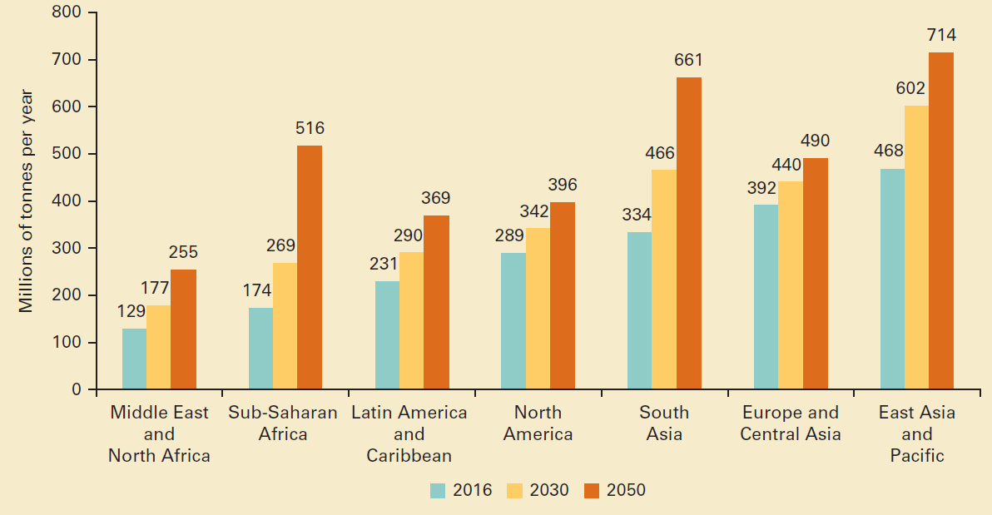

Table 3. Projected waste generation, by region (millions of tonnes/year) [3]

Table 3 shows waste emissions vary significantly by region. But more than that, waste emissions are gradually increasing every year. The increase in waste emissions and the increase in population are directly proportional. The Earth's population is rising rapidly, and many countries are moving beyond the stage of developing countries to the level of developed countries. This evidence shows that waste emissions will only increase further. An increase in waste emissions is inevitable. If so, the only alternative currently is recycling. Although the generation of waste is unstoppable, reducing emissions by reusing is necessary as much as possible. Recently, many companies and countries around the world are recycling. Nationally, citizens are encouraged to recycle by putting a price on waste emissions and establishing a system to ensure good recycling, and companies are making efforts to replace packaging paper and products with recycled products. It is clear that these global efforts have a positive impact on reducing overall waste emissions, but it is also true that they still have obvious limitations.

* 1. **In South Korea**

It has clear limitations of the national recycling system. First, please look at the following table.

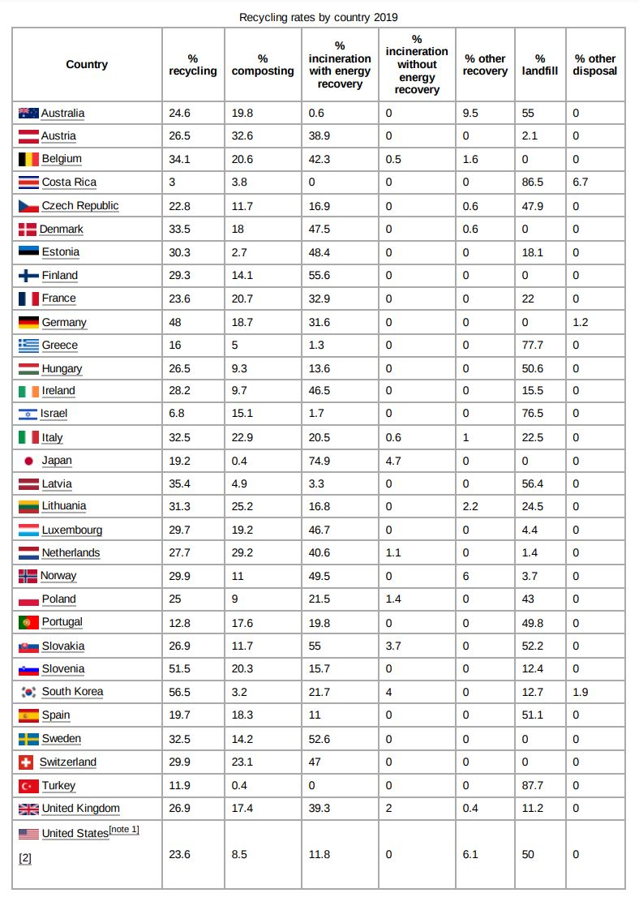

Table 4. Recycling rates by country 2019 [4]

According to Table 4, South Korea has the highest recycling rate. Looking at the numbers, you can see that more than half of the waste is being recycled. Certainly, Korea's recycling system is impressive. Recycling is practiced in almost all residential areas, and the types of waste sorting are incredibly diverse. However, there are still limitations to Korea's tremendous recycling system. The most crucial thing in a recycling system is the waste sorting system. Even though it is clearly labeled as a recyclable product, it is essential to sort the waste because whether or not it can be recycled is determined by how it was used. The problem is that this process incurs a lot of cost. If the sorting cost is within the selling cost, the company that sorts and sells recycling has no reason to accept more recyclable waste.

In early 2021, the ‘garbage crisis’ occurred in Korea. This incident caused great confusion as waste in the Seoul area could not be disposed of for an extended period due to the problems described above and the limitations of facilities such as landfills and incineration. Since then, there has been a lot of interest in Korea's recycling habits. If individuals recycle more thoroughly, there will be less cost for sorting, and the actual utilization rate of recyclable waste may also increase.

Efforts to highlight and resolve interest in and problems with recyclable waste are ongoing. According to '동아경제신문', a Korean newspaper, an event was recently held at the National Assembly of the Republic of Korea to discuss solutions to plastic waste, and according to an announcement at the event. However, plastic was separated and discharged; nearly 40% of it was not recycled. They said it was impossible. (동아경제신문) This clearly shows the country's recycling system's limitations and suggests the importance of individual recycling activities.

* 1. **Research Objectives**

As waste emissions increase worldwide, various environmental problems are occurring. In Korea, in particular, waste management is still complex despite the fact that the recycling system needs to be improved. Although businesses produce far more waste than households, reducing the amount of waste individuals generate can also play a significant role in controlling emissions. Recognizing this problem, the project focused on developed an application that could increase individuals' recycling rates. This application seeks to associate recycling with pleasure rather than obligation. Our goal is to provide various services so that users can enjoy recycling.

The App will include the following features to encourage user recycling. First, it supports the post-upload function for community among users. Second, it supports a function that recognizes and classifies recyclables with a camera, recommends posts accordingly, and suggests ways to recycle them. Lastly, it supports a feature that tracks users' recycling activities.

Through these applications, way for individuals to contribute to protecting the environment has been provided. The goal is to turn recycling into a fun activity and encourage users to participate voluntarily. More than just a tool, this application presents a new approach to environmental protection, an essential step towards a sustainable future.

1. **PROJECT DESCRIPTION**

This section will now cover the overall content of the project.

* 1. **Project Overview**

The project consists of three major stages.

1. Design
2. Required learning
3. Production

Because this project will be produced through an OOP (Object Oriented Program) called 'Swift,' the structure design stage is very important. This is because, after sufficient discussion about the functions required for the application, it is necessary to design classes responsible for and manage each function. More details will be discussed in the next section. Next, let's talk about functional design. The application to be produced in this project will have the following functions.

1. Recyclable product identification function
2. Login, logout
3. User recycling record tracking
4. User post upload
5. Recommended post

Figure 1 is a diagram representing the contents of all the projects described above.

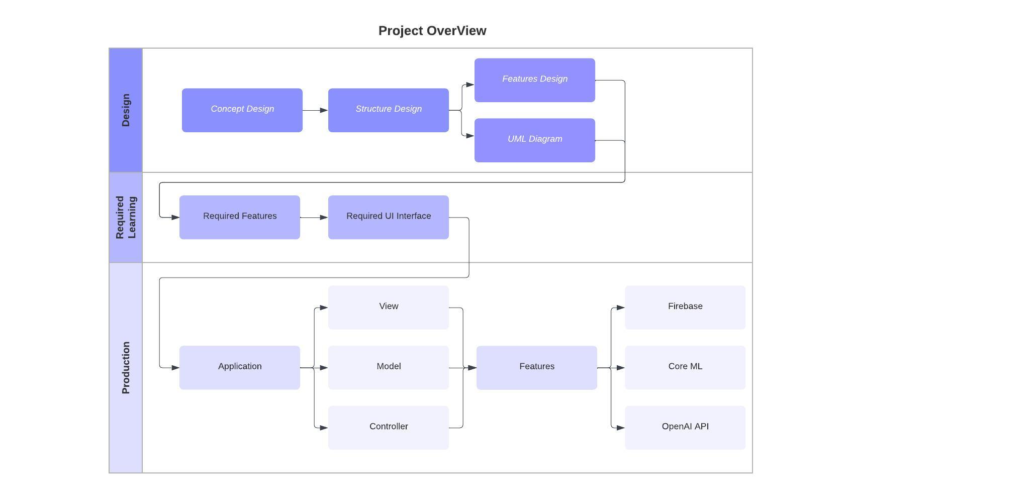

Figure 1. Project OverView

* 1. **Selection of Features**

To perform the functions listed, you must also decide which technologies will be used to perform the functions. The completed function design is as follows.

1. Recyclable product identification function - Core ML (Machine Learning)
2. Login, logout - Firebase Authentication
3. User recycling record tracking - User default storage
4. User post upload - Firebase FireStore, Firebase Store (Database)
5. Recommended post - Open AI API

Three additional technologies to 'Rejoycle' have also added.

1. Firebase
2. Core ML
3. OpenAI API

There are the following reasons for this decision:

1. Firebase

Firstly, Firebase's real-time database feature stands out as a significant benefit. This real-time database is a NoSQL cloud database that synchronises stored data across all clients in real time. Any changes made to the database are immediately reflected on all connected devices, ensuring a highly responsive and interactive user experience. This feature is particularly beneficial for applications requiring real-time updates, such as chat or live streaming services. Furthermore, Firebase's real-time capabilities reduce the complexity and time needed to develop these features from scratch, significantly speeding up the development process.

Another critical advantage of Firebase is its scalability and reliability. Being a Google-backed platform, it offers robust cloud infrastructure, ensuring high availability and automatic scaling to handle demanding workloads. This scalability is crucial for projects anticipating a user base growth or data volume. With Firebase, there is no need to manually manage servers or worry about the database's capacity to handle increased loads. This allows developers to focus more on the application's functionality than its infrastructure.

Lastly, the fact that it provides a large amount of data traffic for free was also a big reason for using Firebase. This is a very positive reason as we have not yet received financial support from outside.

1. Core ML

Core ML is a program Apple provides for Xcode users to create machine learning quickly. Of course, some systems convert other pre-made machine learning to use in Swift. This gives developers a vast range of options. Also, as machine learning is not the core content of the project, the main reason is that much time can be saved in producing machine learning.

1. OpenAI API

The OpenAI API provides many, many features. Features provided include an AI chatting function, voice recognition function, and image creation function. The function that will be applied to our project is called ‘Text generation’. This function sends the desired content to OpenAI in a JSON file format, and the appropriate content is returned. The usefulness of this function cannot be overstated. First, it can provide new content through a massive amount of information every time. If this feature had not been applied to application, it should have had to write a vast amount of recycling-related content ourselves. In other words, it is a great technology that saves time and space. Additionally, because Apple helps connect to Xcode more easily through a package, accessibility can also be considered very good.

Lastly, there is the production process. In creating the application, there were many challenges to implementing the pre-determined design and features.

1. **METHODOLOGIES: Technologies and Features of this project**

The discussion now shifts from the overall project flow to a detailed explanation of the technologies that will be utilized to operate the included functions. This will encompass a comprehensive description of each technology, along with its characteristics, advantages, and disadvantages.

* 1. **Technical Details**
     1. **Swift & Xcode**

Swift and Xcode are key components in Apple's ecosystem for developing apps. Swift is a programming language, while Xcode is the software tool, or Integrated Development Environment (IDE), used to write and test that code.

Swift is Apple's programming language, designed for building iOS, macOS, watchOS, and tvOS apps. It's known for being powerful yet easy to learn and use. Swift is efficient and fast, making it an excellent choice for modern app development. It's designed with safety, helping developers avoid common coding mistakes. One of the unique features of Swift is its compatibility with another Apple programming language, Objective-C, allowing developers to use both in the same project.

Next, Xcode is the primary tool used to write apps for Apple's platforms. It's a powerful IDE that supports both Swift and Objective-C. Xcode simplifies the process of writing code, debugging, and testing apps. It comes with a user interface editor, which makes it easy to design the layout of your app visually. The code editor in Xcode is also quite advanced, offering features like auto-completion and syntax highlighting to make coding more manageable. Another significant aspect of Xcode is its ability to simulate different Apple devices, allowing developers to see how their apps would run on various iPhone, iPad, or Mac models. This is crucial for ensuring that apps provide a great user experience on all devices.

Together, Swift and Xcode provide a comprehensive environment for app development. Swift's efficiency and ease of use, combined with Xcode's powerful tools, make developing Apple apps more streamlined and accessible. Whether you are a beginner or an experienced developer, Swift and Xcode can help you bring your app ideas to life.

* + 1. **UIKit**

UIKit, "User Interface Kit," is a fundamental framework developers use for building user interfaces in iOS applications. It provides a wide range of predefined interface elements, such as buttons, text fields, sliders, and more, which developers can use to create intuitive and aesthetically pleasing app designs.

UIKit is known for its ease of use and flexibility. It allows developers to create interfaces that are not only visually appealing but also highly functional and responsive. UIKit works seamlessly with other key frameworks in iOS, such as Core Data for data management and Core Graphics for advanced graphical rendering, enabling developers to build complex and sophisticated apps.

Despite its strengths, UIKit does have some limitations. As iOS has evolved, newer frameworks like SwiftUI have emerged, offering more modern and efficient ways to build user interfaces. SwiftUI, with its declarative syntax, is gradually becoming the preferred choice for many developers, especially for building more complex, dynamic interfaces.

In conclusion, UIKit has played a vital role in developing iOS applications, offering developers a comprehensive set of tools for building user interfaces. Its evolution over the years has mirrored the advancements in iOS technology and user interface design. While newer technologies like SwiftUI are gaining prominence, UIKit remains a fundamental part of iOS development, especially for developers who value its familiarity and wide range of features.

* + 1. **OOP (Objected Oriented Program)**

Object-Oriented Programming (OOP) is a programming paradigm that uses "objects" to design software. Unlike traditional programming models which focus on functions and logic, OOP centers around objects that represent real-world entities. An object in OOP is an entity that contains data in the form of fields, often known as attributes, and code, in the form of procedures, known as methods.

The concept of OOP is built on several key principles, namely encapsulation, inheritance, and polymorphism. Encapsulation refers to bundling the data and the methods that operate on the data within one unit. This not only helps in keeping the data safe from outside interference and misuse but also enhances the modularity of the program. Inheritance allows one class to inherit the properties and methods of another class, promoting code reusability and the creation of a more logical hierarchy. Polymorphism enables objects of different classes to be treated as objects of a common superclass, allowing the same interface to be used for different underlying forms of data.

One of the main advantages of OOP is its ability to model complex systems in a more understandable way. By breaking down the system into smaller, manageable objects that mimic real-world entities, OOP makes it easier for programmers to conceptualize and maintain complex applications. This approach also improves code reusability, as objects and classes can be reused across different parts of a program or even in different programs.

Moreover, OOP enhances maintainability and scalability. Because of its modular nature, changes made in one part of the application usually require minimal changes in other parts. This modular design also makes it easier to scale the application, as new objects can be created with little to no modification to existing code. Furthermore, OOP's focus on encapsulation ensures that the internal workings of objects can be changed without affecting other parts of the application, which is particularly useful for dealing with bugs and improving the performance.

* + 1. **MVC model (Model-View-Controller)**

The MVC (Model-View-Controller) Model is a design pattern effectively utilized in smartphone application development. It structures an application into three interconnected components, each with a specific role, which helps organize code, making it more manageable, maintainable, and scalable. Now, I will explain each role.

1. Model

In smartphone applications, the Model represents the data and the business logic. It's where the app's core functionality resides, handling data processing, database interactions, and business rules.

1. View

The View is the user interface of the application. It displays the data from the Model to the user and handles user interactions. In smartphone apps, the View consists of all the UI elements like buttons, text fields, images, etc.

1. Controller

The Controller is the intermediary between the Model and the View. It processes user input received through the View, requests the Model for data or to carry out actions, and then updates the View accordingly. In a navigation app, for instance, the Controller would take the user's destination input, request the route information from the Model, and then direct the View to display the route.

The MVC model is particularly beneficial for smartphone apps due to its separation of concerns. The Model handles all the logical processing, the View focuses on the visual representation, and the Controller bridges the two. This separation allows developers to modify one aspect of the app (like changing the UI layout) without needing to rewrite the business logic. It also makes testing and debugging the app easier, as each component can be worked on independently.

In summary, the MVC model in smartphone applications provides a clear structure for development, dividing the app into three main components: Model, View, and Controller. This not only aids in keeping the codebase organized but also enhances the development process by allowing for easier maintenance and scalability.

* + 1. **Firebase**

Firebase is a comprehensive app development platform offered by Google, known for its ease of use and efficiency in building and managing apps. It provides a suite of tools that help developers at every stage of development, from building the app to improving and growing it. Firebase has many features, but I will specifically explain three features that will be used in this project.

1. Firebase Authentication

This service simplifies user authentication processes. It supports various sign-in methods, including email/password, phone numbers, and popular social media platforms like Google, Facebook, and Twitter. Firebase Authentication is designed to be easy to implement and secure. It takes care of all the complexities associated with user authentication, such as password recovery and account verification, allowing developers to focus more on the app's core functionalities.

1. Firebase Cloud Firestore

Cloud Firestore is a flexible, scalable database for mobile, web, and server development. It allows for real-time data synchronization, meaning that any changes in the database are immediately reflected in the app. Cloud Firestore is also highly scalable, ensuring the database performance remains robust as the app grows.

1. Firebase Storage

Designed for app developers who need to store and serve user-generated content, such as photos or videos, Firebase Storage provides secure file uploads and downloads for Firebase apps. It's built on Google Cloud Storage, ensuring scalability and reliability.

Firebase offers several advantages. It greatly reduces development time by providing ready-to-use services that are easy to integrate and manage. Its scalability ensures that the app can handle growth in user numbers and data without the need for significant changes in the infrastructure. Firebase also enhances the user experience by providing services like real-time database updates and secure, efficient authentication processes.

* + 1. **Core ML**

Core ML is Apple's machine learning framework, designed to integrate machine learning models into iOS, macOS, watchOS, and tvOS apps. It's a powerful tool allowing developers to easily incorporate advanced machine-learning capabilities into their applications.

At its core, Core ML enables apps to use machine learning to perform tasks like image recognition, natural language processing, and prediction based on complex data patterns. The framework supports various model types, including neural networks, decision trees, and support vector machines.

One of the critical advantages of Core ML is its optimization for on-device performance, which means it can run models efficiently on Apple devices. This is crucial for maintaining user privacy and ensuring low latency. Core ML keeps user data private and secure by processing data directly on the device rather than sending it to a server.

Furthermore, Core ML is designed to be easy to use. It provides a straightforward process for integrating pre-trained machine-learning models into an app. Developers can use models trained with various popular machine learning tools and convert them to Core ML format using Apple's Core ML Tools.

In summary, Core ML is a robust, user-friendly framework that brings advanced machine learning functionalities to Apple's platforms. Its focus on on-device processing ensures high performance and user privacy, making it a valuable tool for developers looking to incorporate machine learning into their applications.

* + 1. **OpenAI API**

The OpenAI API is a powerful tool developed by OpenAI, providing developers with access to advanced artificial intelligence models. This API is designed to integrate AI capabilities into various applications, websites, and software systems, making cutting-edge AI technology more accessible and usable for various purposes.

1. Natural Language Understanding and Generation

The API is widely used for tasks that involve understanding or generating natural language. This includes chatbots, virtual assistants, content creation tools, and more. It can generate coherent and contextually relevant text based on input prompts.

1. Content Creation and Summarization

The API can assist in creating content like articles, reports, and stories. It's also adept at summarizing long texts into concise versions, making it useful for quickly digesting large amounts of information.

1. Language Translation

The API includes capabilities for translating text between various languages, which can be integrated into translation tools or services.

1. Image Generation

With models like DALL-E, the API can generate images and art from textual descriptions, offering a new way to create digital artwork and visual content.

In summary, the OpenAI API is a versatile tool that opens a wide range of possibilities for integrating advanced AI functionalities into various applications. Its ability to understand and generate human-like text and images makes it an asset for developers looking to harness the power of AI in their projects.

1. **DEVELOPMENT**

This content explains the application development process. The process of application UI development and function development is included. After presenting the development, I will explain some impressive challenges and the process of discovering solutions.

* 1. **Development Process**

First, a UML (Unified Modeling Language) was drawn to visualize the structure of the application. The creation of UML diagrams facilitated a cleaner MVC (Model-View-Controller) pattern. This diagram (Figure 2) represents the final version.

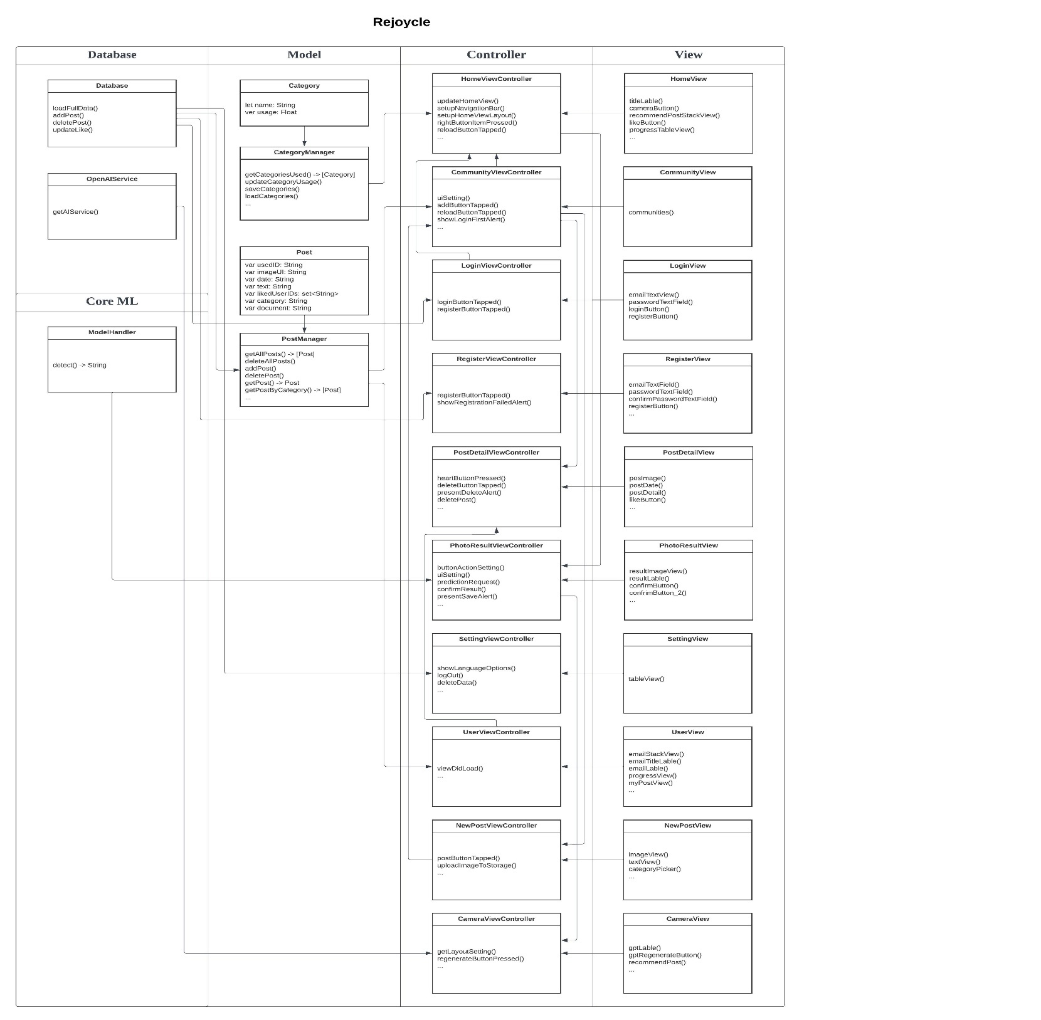

Figure 2. Rejoycle UML diagrams

* + 1. **View & Model & Controller**

Next, the user interface code for each View was written. Despite some repetitive tasks, significant effort was required to create a variety of interfaces. A total of six types of interfaces were used. The instances where a unique UI is employed will be explained.

* + - 1. **HomeView**

HomeView was constructed using UILabel, UIButton, and UIStackView. The screen was then assembled by adjusting the position of each UI element using auto layout. When creating each UI element, it is crucial to effectively utilize their characteristics. Understanding the available design features proves to be very helpful. The primary resource for consultation was the official documentation provided by Apple. Through out Figure 3, it is easy to follow the way how HomeView works in App. For more detailed information about the code, please refer to ‘Appendix 1’.

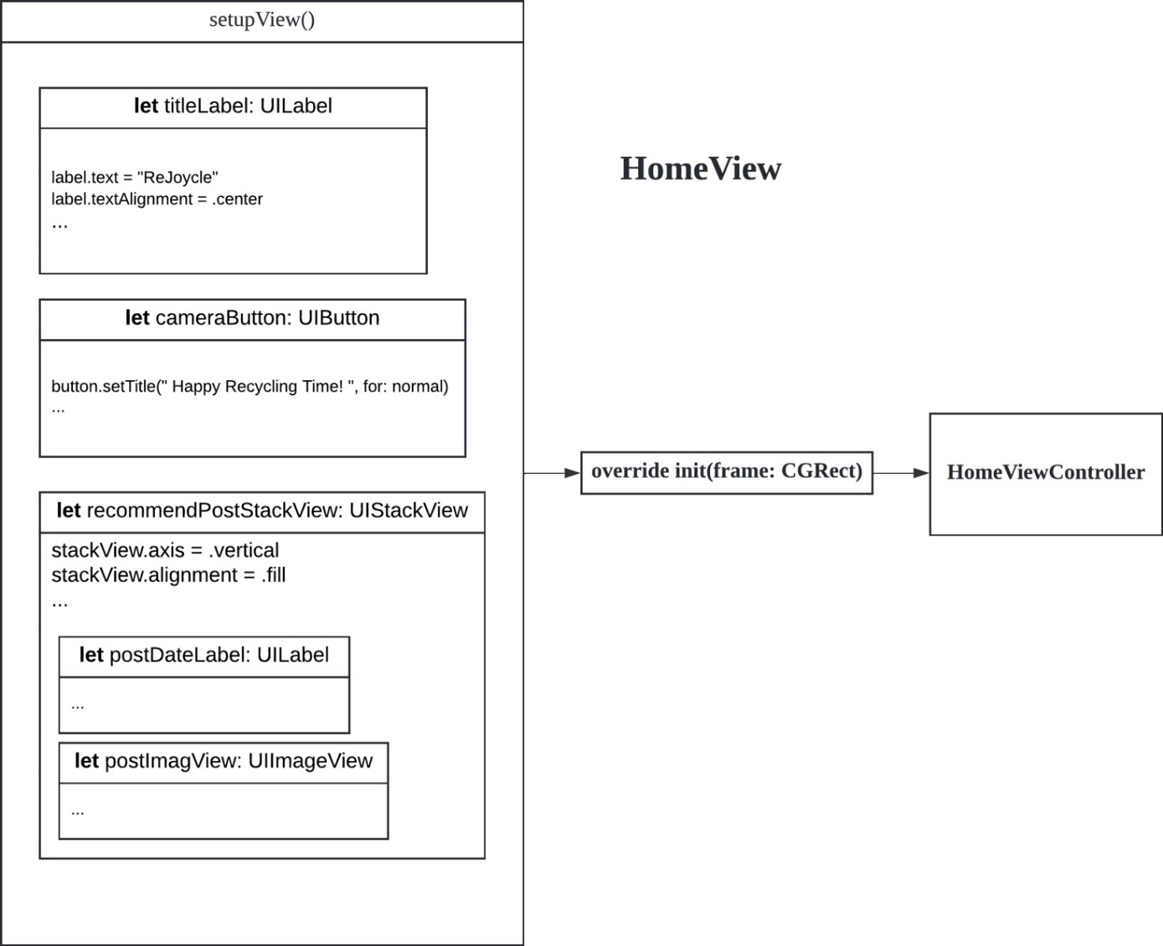

Figure 3. HomeView Flow Chart

Figure 4 is screen how the HomeView works in smart phone.

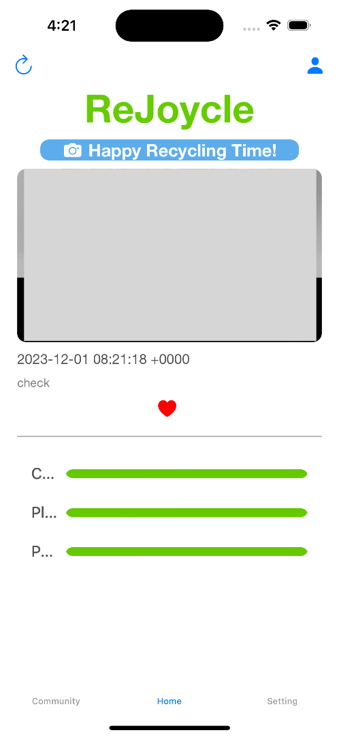

Figure 4. Screenshot HomeView

* + - 1. **CommunityView**

In Figure 5, CommunityView used UITableView. This is connected explicitly to CellView and is intended to display items sequentially in either the vertical or horizontal direction. If you want more details, please refer to ‘Appendix 2’.

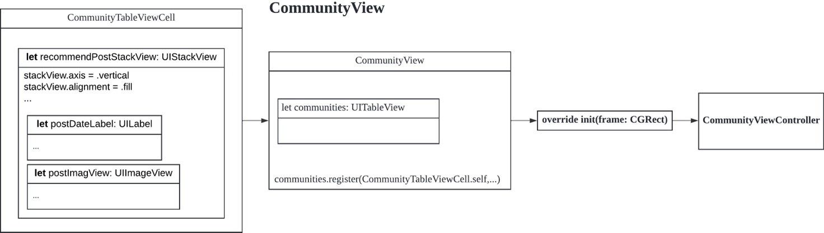

Figure 5. CommunityView Flow Chart: UITableView

For UITableView, connection with the controller is significant. This is because the controller is responsible for the number of items in the UITableView and the functions executed when an item is tapped, so it must be connected to appear on the user's screen. Figure 6 and Figure 7 can give more understand about the connection. If you look at 'Appendix 3', you can see how UITableView was managed through Delegate.

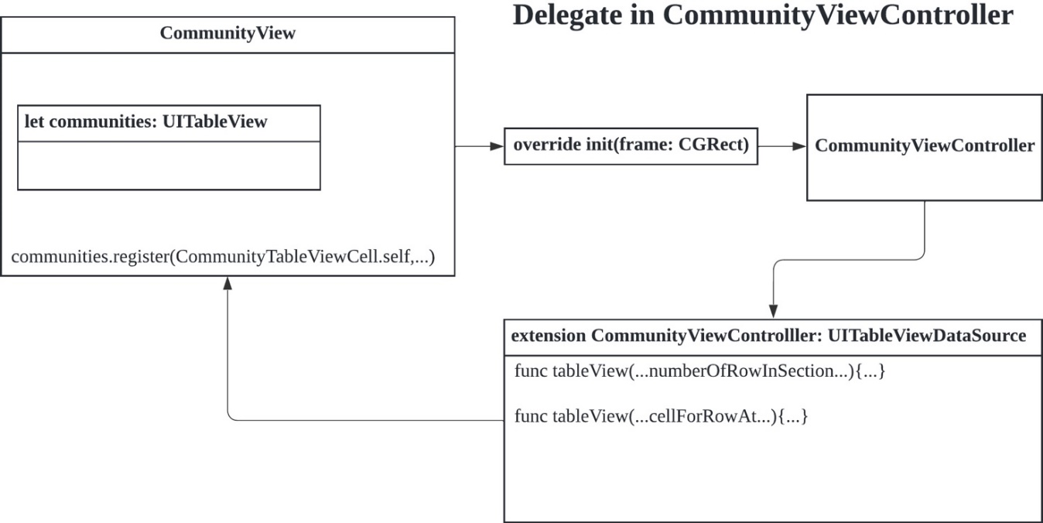

Figure 6. Delegate in CommunityViewController: Control UITableView.

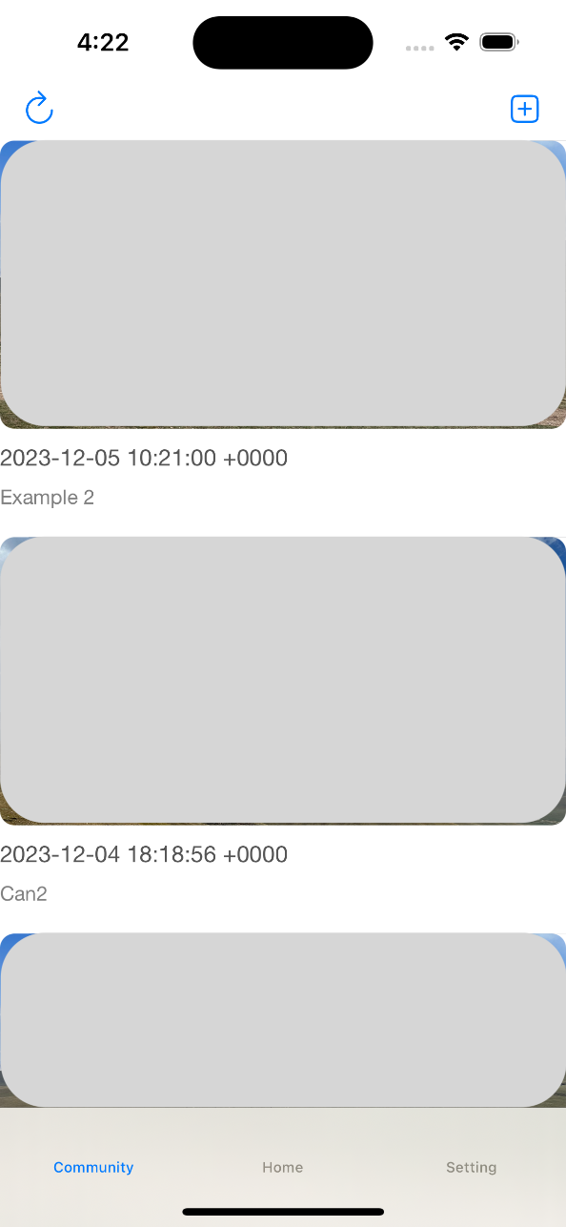

Figure 7. Screenshot UserView

* + - 1. **UserView**

In UserView, UICollectionView was specifically utilized. This component shares similarities with UITableView, but it notably arranges items in a tile pattern (Figure 8). The connection with the controller in this context is also significant. The flow of UICollectionView follows the same pattern as that illustrated in Figure 6; hence, no separate diagram was created. For an in-depth comparison between UITableView and UICollectionView, please refer to ‘Appendix 4’.



Figure 8. Screenshot UserView

* + - 1. **NewPostView**

NewPostView uses something called UIPickerView (Figure 10). This allows the user to choose what they want from the given options. In this application, UIPickerView, a view that looks similar to a roller, enables users to determine the categories that their posts will contain. If you want more details about the code, please refer to ‘Appendix 5’ and ‘Figure 9’.

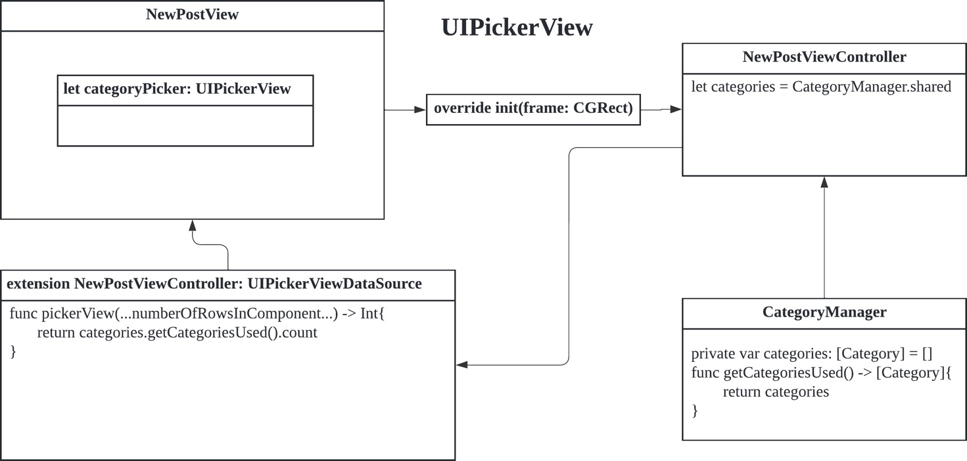

Figure 9. NewPostView Flow Chart: UIPickerView.

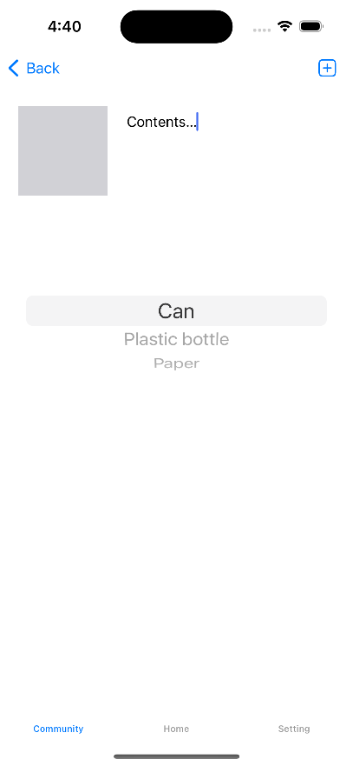

Figure 10. Screenshot NewPostView

A much more considerable amount of code was required to create the user interface than the amount introduced previously.

* + - 1. **Model**

Following Figure 11 and 12, a model was developed, including types such as Post and Category. These models were essential, as they cater to the data storage needs both locally and, in the cloud, encompassing the types of posts users will write and the varieties of items users recycle.

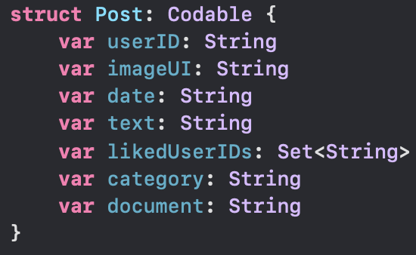

Figure 11. Some code from Post

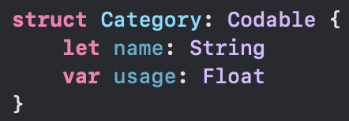

Figure 12. Some code from Category

After completing the model, the next step is to create a class to manage the model. Figure 13 is the outline.

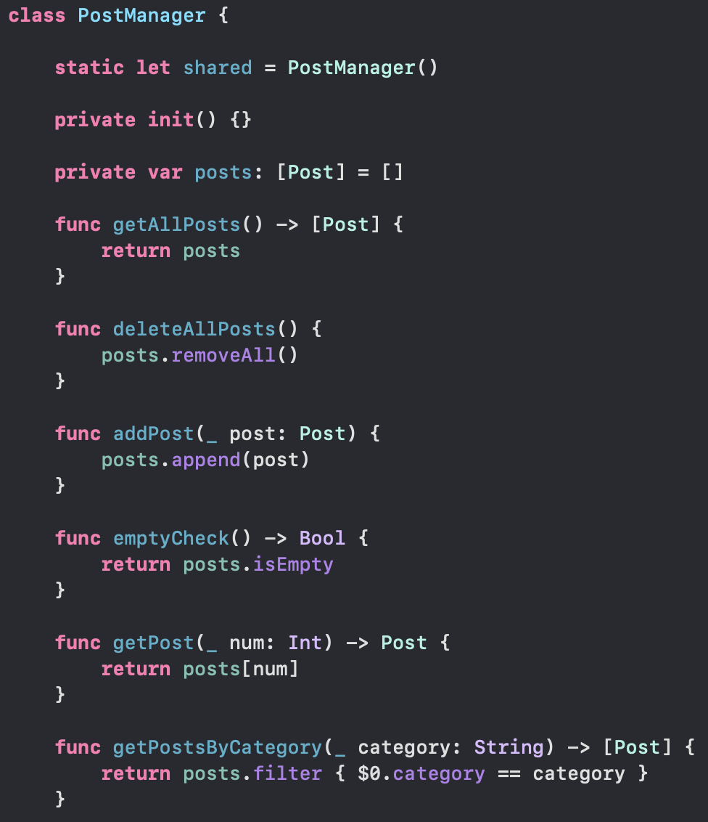

Figure 13. Some code from PostManager

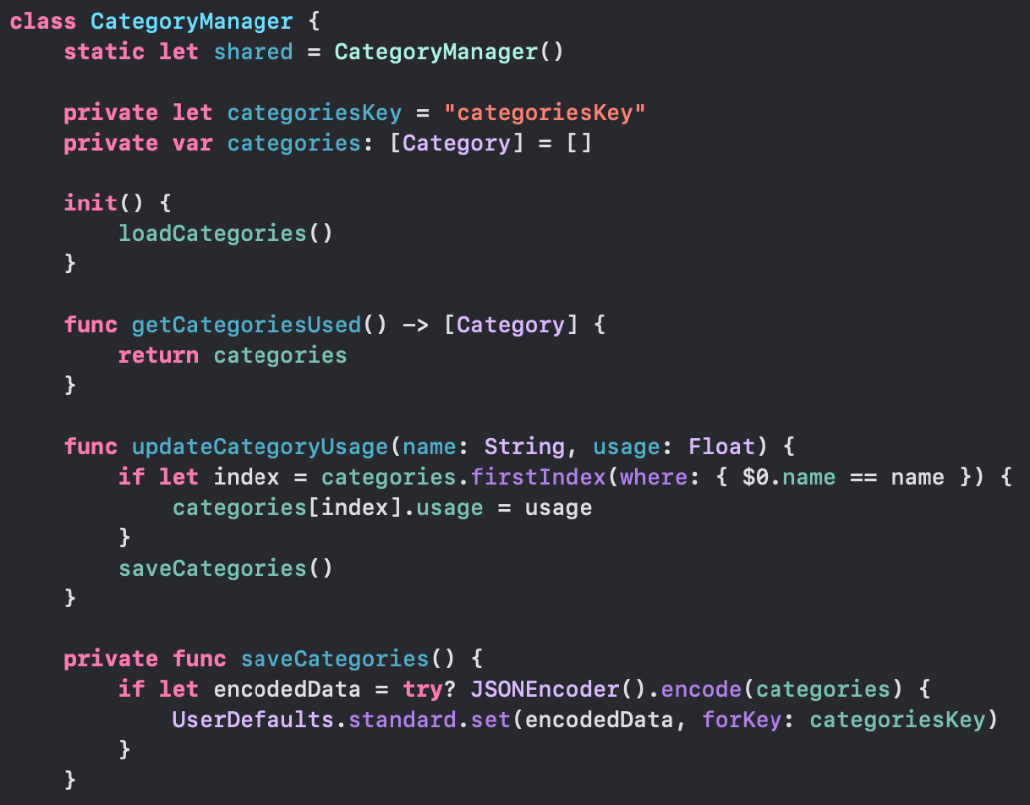

Figure 14. Some code from CategoryManager

The functions written in Figures 13 and 14 are executed in connection with the Controller. And the UI is reorganized through connection with the View in the Controller.

* + - 1. **Controller**

Now, the next step is to build the Controller. Controllers can be seen as the core of application creation.

Because the Controller manages the app's life cycle, it also enables the switching of screens. The approach to screen navigation was implemented in two ways. Initially, TabBarViewController is utilized, as shown in Figure 4, where a tab at the bottom displays 'Community, Home, Setting.' TabBarViewController is the class that controls the operation of this tab.

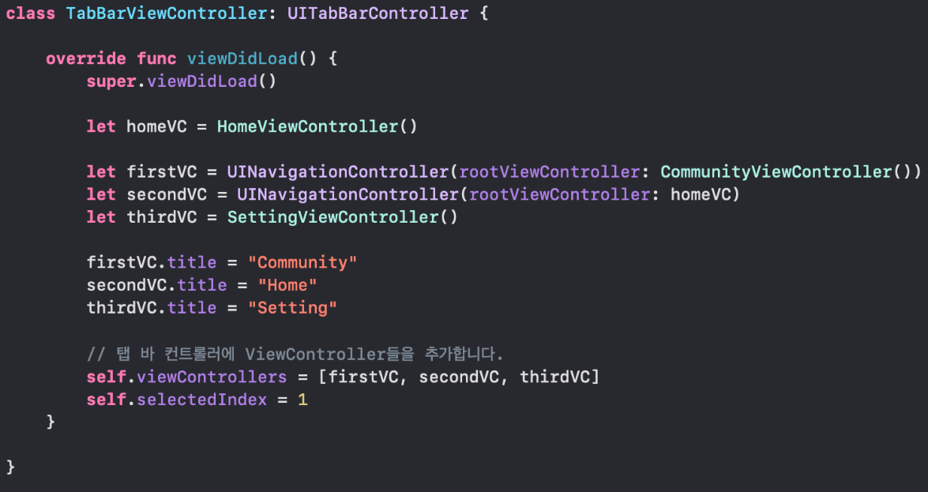

Figure 15. TabBarViewController

As shown in Figure 15, you can check both methods mentioned above on this screen. There is UITabBarController, which was explained first, and the second one is UINavigationController. Both have the same function, but their uses are different. Controllers not only manage screen transitions but also manage data conversion within the screen.

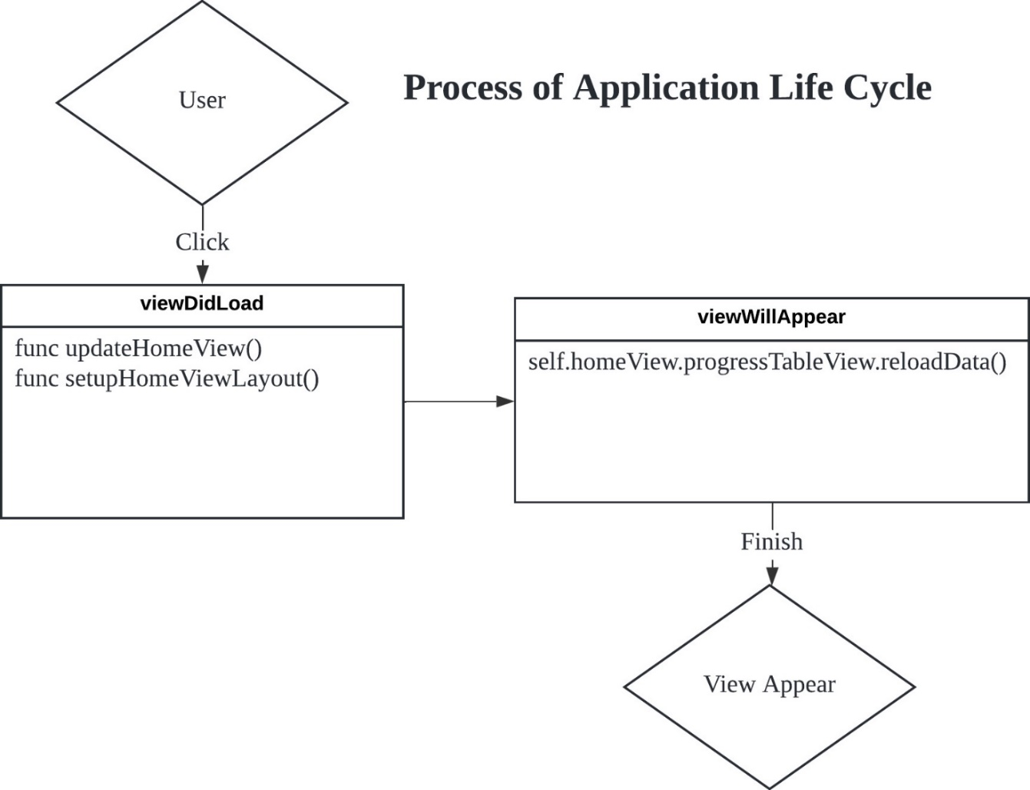

Figure 16. Application Life Cycle.

If you look at Figure 16, there are two functions: viewDidLoad and viewWillAppear. As you can see from the name, these are functions that are executed during the process of creating and disappearing a view. Of course, there are several more functions between these two functions. The important thing is to accurately check when these functions are activated and manage the necessary screens. Therefore, updateHomeView, which sets HomeView's UI, is executed before the view is created. If you want to know more about functions running in viewDidload, please check 'Appendix 6'.

The controller also manages button actions. Figure 17 introduces the method.

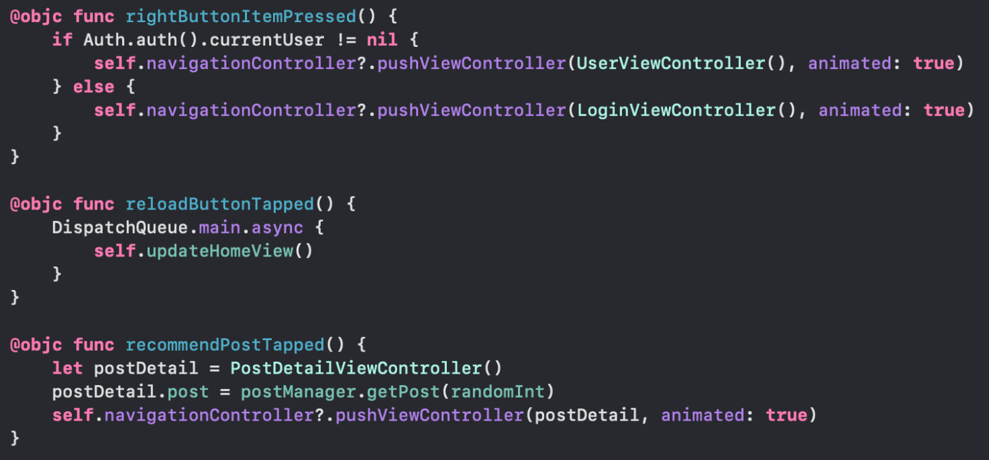

Figure 17. Some code from HomeViewController

The functions that operate in the controller were introduced and their application explained. Next, an explanation will be provided on how the functions used in this application are applied.

* + 1. **Firebase**

A total of three Firebase technologies are applied to this application. There are technologies for managing user accounts, managing user posts, and managing user feedback and photos to be uploaded to user posts. First, let's look at how Firebase is applied. Two processes are required to apply Firebase. First, use the project to be involved on the Firebase homepage (Figure 18).

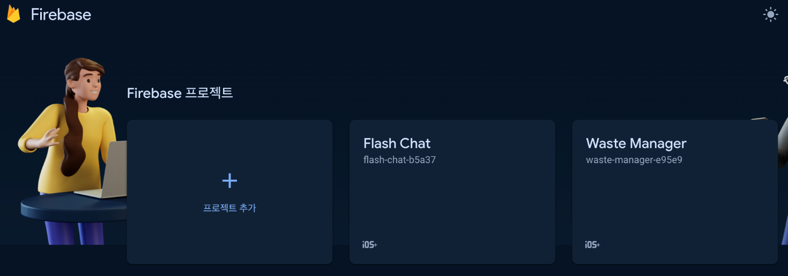

Figure 18. Firebase Homepage

Next, download and use the Firebase package within Xcode (Figure 19). Since Firebase supports Xcode, it can be applied through a straightforward process.

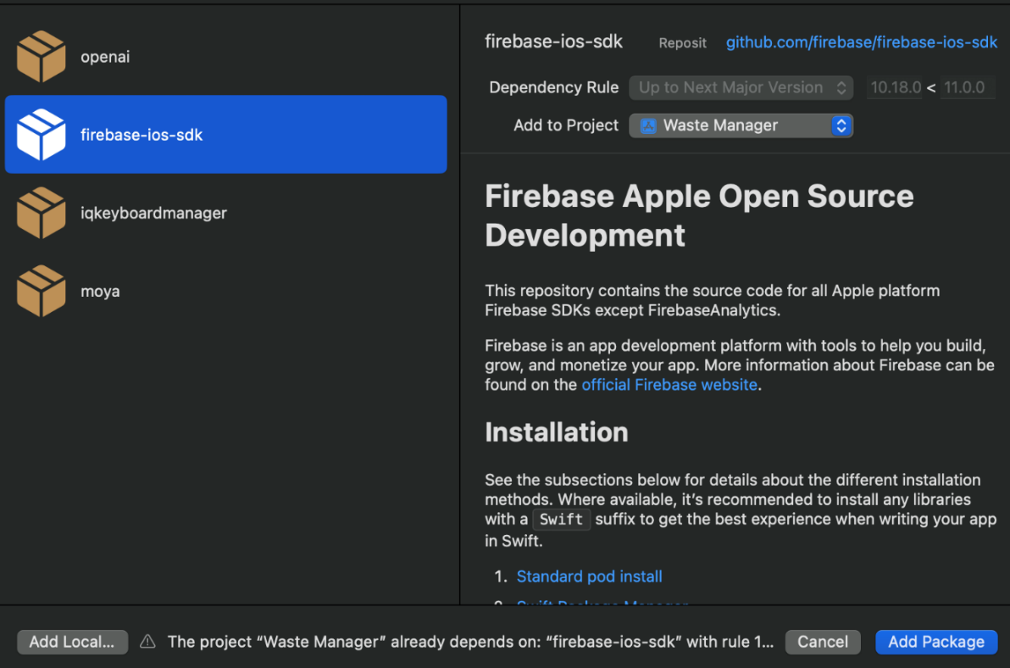

Figure 19. Firebase Package

Next, explanation about the system for managing users will be provided. Firebase handles user login, logout, registration, etc., through a library called FirebaseAuth.

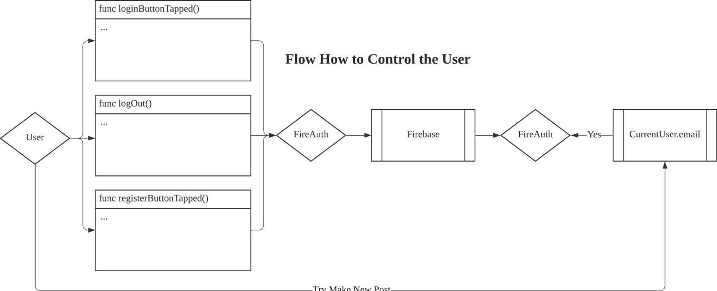

Figure 20. Flow How to Control the User

Figure 20 is a diagram explaining the flow of managing a user's account. Understanding this flow is very important. This is because it is necessary to accurately determine whether a user is currently logged in or not to track all user actions and save data for each user. To check the functions that manage login, logout, and registration in more detail, see 'Appendix 7'.

Next, the focus shifts to explaining the database management service, highlighting the choice of Firebase for the application. The most important thing here is that it must always be able to manage local data created with the Model and data stored in Firebase so that it matches completely.

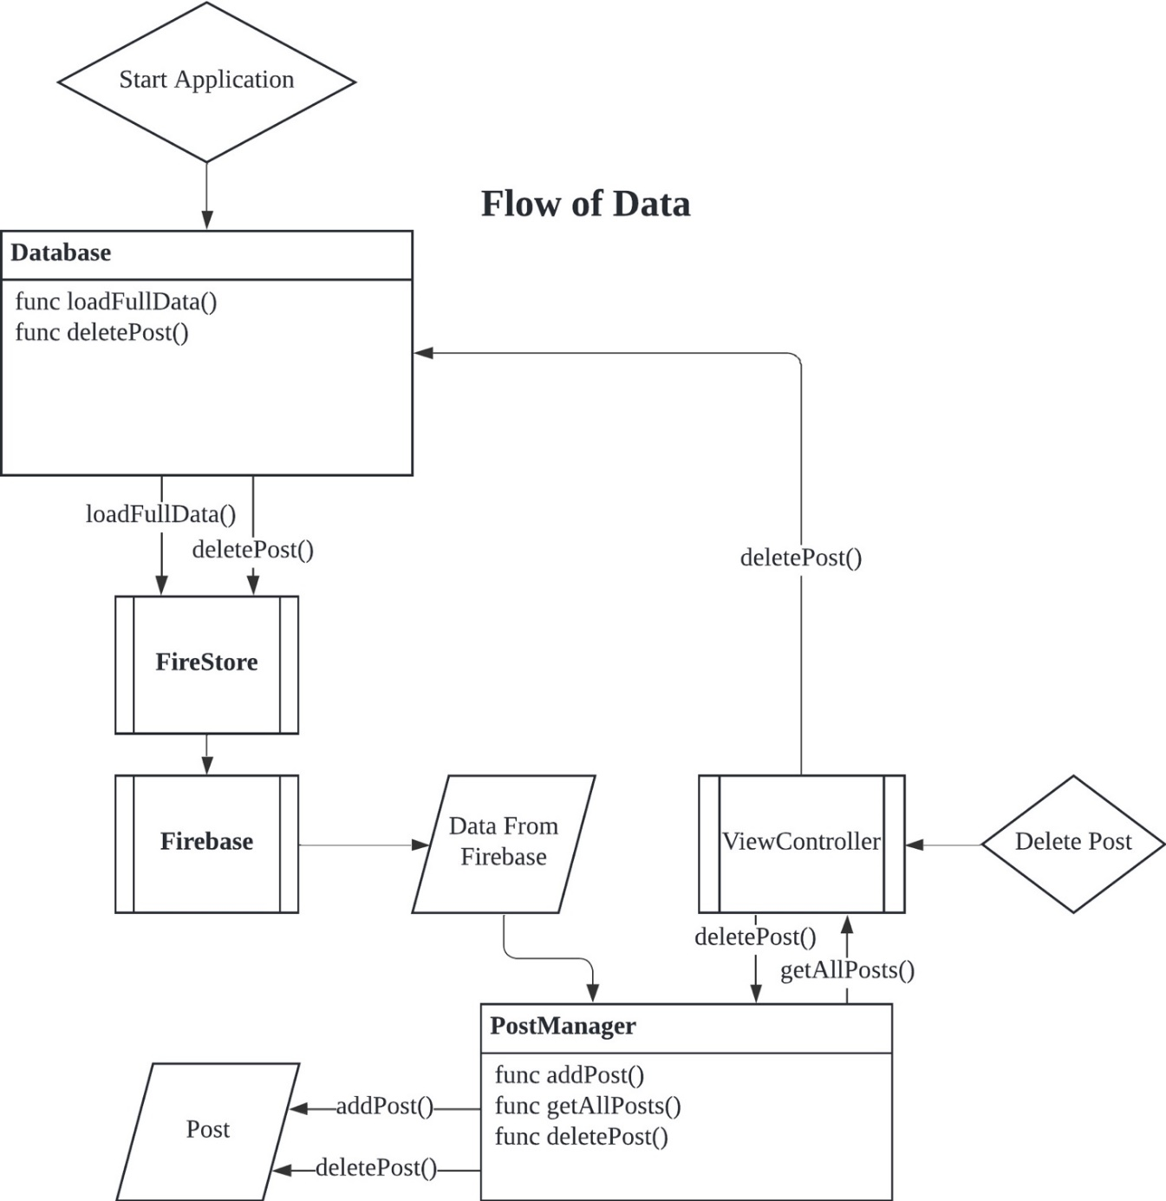

Figure 21. Flow of Data.

Figure 21 is a diagram expressing the final data flow. The synchronisation of local and cloud data needs to be looked at most carefully. Figure 21 shows adding and deleting posts, but many more functions go between Firebase and the application. If you want more details, please check ‘Appendix 8’ and ‘Appendix 9’.

Firebase's Firestore plays a perfect role as a database. But there is one problem. Photos are essential to our application. There is no means in Firestore to store pictures that users upload to posts. Therefore, Firestorage was installed, saved the photos in Firestorage, and saved the photo URL in Firestore so that users could view the pictures on the screen. Figure 22 will help you understand more.

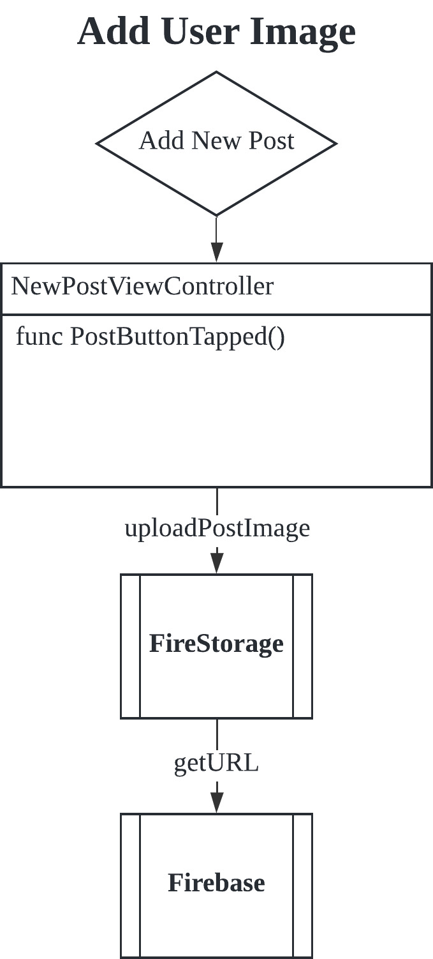

Figure 22. Add User Image.

In addition, users can save photos of recycled products viewed with a camera in Firestorage to improve machine learning further. If you want to know more about saving user images and feedback, please refer to ‘Appendix 10’.

* + 1. **Core ML**

Core ML is machine learning created by Apple for developers using Xcode so that machine learning can be produced easily compared to other systems.

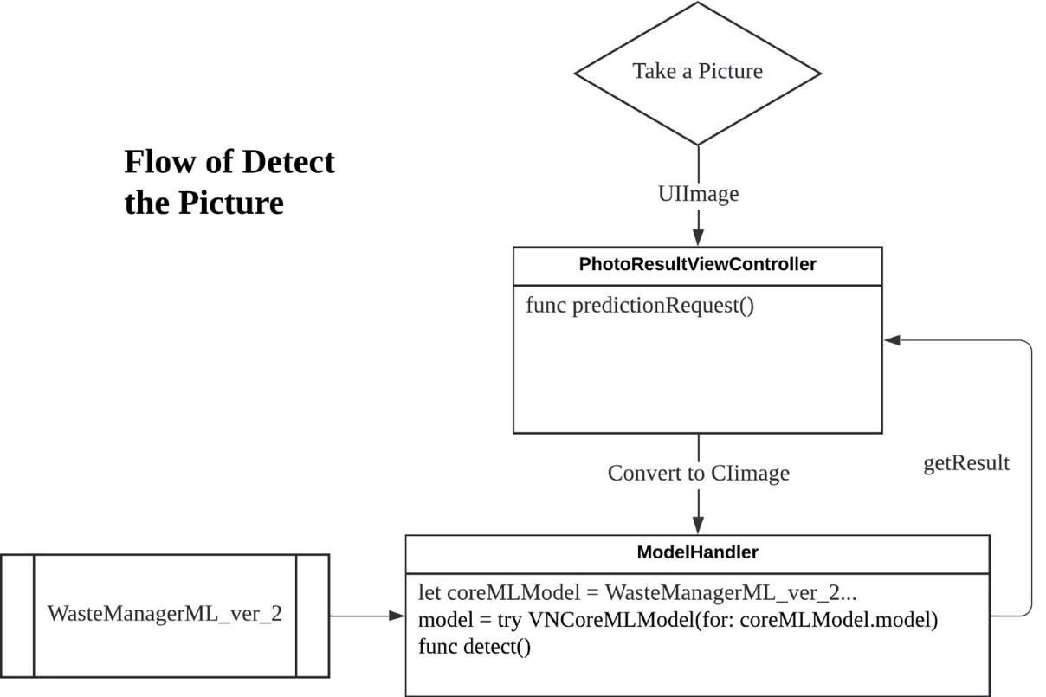

Figure 23. Flow of Detect the Picture.

If you see the Figure 23, there are several necessary processes to classify images using machine learning. First, it is required to convert photos taken with a camera into CIImage, then convert WasteManagerML_ver_2, a pre-trained model, into VNCoreMLModel. Detailed code for Core ML is written in 'Appendix 11'.

* + 1. **OpenAI API**

The OpenAI API can be used by installing the OpenAI package. All data is exchanged in JSON file format. Since all models have already been created in JSON format in the installed OpenAI package, you can conveniently receive data from the OpenAI API. Figure 24 is the process of receiving data from the OpenAI API and then displaying it on the interface. Detailed information on each function is written in ‘Appendix 12’.

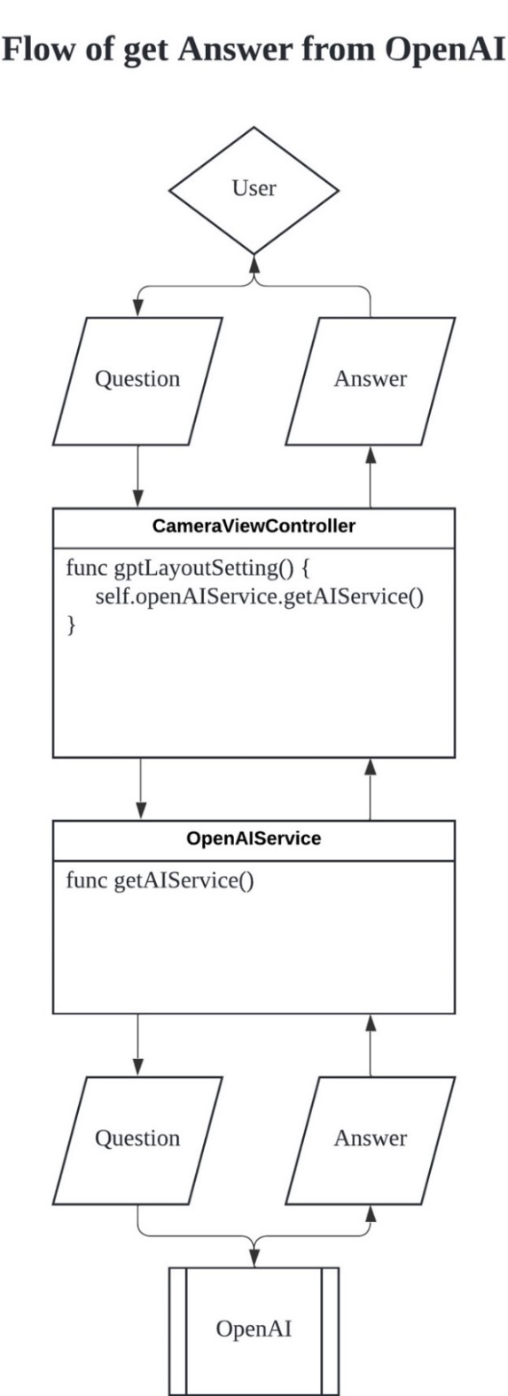

Figure 24. Flow of get Answer from OpenAI.

* 1. **Challenges and Solutions**

The entire process of completing the project presented significant challenges and learning opportunities. This section aims to discuss some of the more time-consuming challenges encountered and explain the approaches taken to find solutions.

1. Data sharing between Controllers

Data must be exchanged between classes, but if each class defines and uses new data every time, the data held by each class is not connected, so when modified on one side, it will not be modified at all on the other. This problem is a common phenomenon in an object-oriented program (OOP). You can use a pointer to directly limit the same data between classes by using the data address, but Swift does not recommend that. So, it took a lot of time to think about methods that could be used in Swift.

This problem was solved using 'shared.' 'Shared' assists in recognizing it as the same class, even when defining a new class that manages data in a different class each time. This makes it possible to share and modify data between classes without having to use the address of the data directly by using a pointer every time.

1. How to save images to a database

Storing users' images in real-time in the database and the cloud is significant. However, Firebase Firestore did not support saving images. There was certainly an alternative to saving pictures and videos called Firestorage. Still, the problem was how to properly hold and load the post to be kept in Firestore and save the image in Firestorage.

Many times, information was sought through Google searches. However, discerning the best method proved challenging. Assistance from ChatGPT was invaluable in this context. With a clear understanding of the problem, direct answers were obtained when queries were posed to ChatGPT. The solution identified was the utilization of URLs. In Firestore, which primarily stores types like String or Int, managing users' images was achieved by saving the URL as a String type each time. Although this approach involved some loading time, it represented the optimal solution at the moment.

1. **MARKET RESEARCH**

'Rejoycle', which we produced, has a non-profit nature. However, periodic costs are inevitable to operate the application. And a strategy is essential to cover those costs.

* 1. **Market Strategy**

First, cost to run the application was calculated. It was calculated on a yearly basis.

|  |  |
| --- | --- |
| List | Expense |
| Apple Developer Program | 99.00$ |
| OpenAI API Service | 200.00$ |
| Total | 299.00$ |

Table 9. Cost estimate table

In Table 9, price is the budget when calculating the initial number of users and usage when the app is released on the Apple Store for the following year. If the number of users exceeds expectations, additional costs may be incurred.

So how can these costs be covered? Getting sponsorship from users is a solution. The decision was made to pursue individual sponsorship, as the costs were deemed too minimal to warrant collaboration with companies or other organizations. Sponsorship will be provided through crowdfunding.

How should marketing be conducted now? The most crucial aspect is to convey the social value of the application as a non-profit entity. The strategy includes communicating this value in two ways: user feedback from social media and the app store.

* 1. **Competitive Analysis**

To survive in the market, you must study your competitors and conduct marketing by emphasizing your strengths. Research shows that the AppStore currently has

At this point, there isn't an application similar to 'Rejoycle.' There are no applications that recognize recycled products using machine learning, and there are no applications that provide community services to share recycling cases. Therefore, by successfully leveraging these characteristics in marketing efforts, positive results can be anticipated.

1. **FUTURE DIRECTIONS & PLANS**

Strictly speaking, 'Rejoycle' is an unfinished application. Many things can still be improved, and more services are needed. In this chapter, the focus will be on describing how and what plans are set to continue even after the project's completion.

* 1. **Enhancing Technical Capabilities**

The most crucial development priority is multilingual support services. Currently, 'Rejoycle' only supports English, making it difficult to demonstrate its capabilities sufficiently in Kazakhstan. Therefore, servicing Kazakh and Russian is necessary with followed by other languages.

Next is the issue of loading speed. Currently, when running the application, images are loaded at a significantly lower speed than the supported Internet speed. This is probably because it is an application that has yet to be certified by Apple, so Firebase also sends data after going through several tests.

There is also an intention to provide a service that allows users to comment on each post. Currently, users can only express their opinions through the 'Like' button, which highlights the need for this additional feature.

* 1. **User Experience and Interface Improvements**

Improving the user experience is very important. The user experience can be improved by further developing the interface and the user community. First of all, a few parts of the interface currently need to be added. There are ‘SettingView’, ‘CameraView’, etc. In the case of ‘SettingView,’ there are not many services yet supported, so there is a lot of space. It seems essential to design by making good use of this space. Next is ‘CameraView’. This view is a window where you can see the results after taking pictures of recyclables. It displays the data received from OpenAI on the screen. However, this screen still has many shortcomings. It seems like a lot of moorings will be needed in the future.

Next is how to improve community services. Our plan now is to create groups of users so they can communicate. Currently, the service only allows users to post individual posts. Still, creating groups and providing a service for each group is planning to enable users to share their experiences and thoughts. This service is expected to make a more outstanding contribution to encouraging recycling.

* 1. **Long-Term Vision and Goals**

There are three goals: to join the AppStore, to serve in Korea, and to become a representative of recycling applications. These goals will be progressed in sequence.

First, the plan is to apply for AppStore registration by completing as many of the previously explained items as possible. This is an ambitious goal for the project, considering the AppStore's subscription conditions are more stringent than those of other application stores. The next objective is to provide service in Korea, a decision influenced by personal experiences with the waste problems currently faced in Korea and the urgent need for solutions. Service in Korea is a primary goal, being a major motivation behind this project. Finally, the aim is to become the most representative application among those encouraging recycling. Research indicates a lack of competing applications, suggesting that this goal can be achieved through constant updates and marketing.

**CONCLUSION**

In this project, the design and analysis of a 'Rejoycle' App is presented. Rejoycle is a waste sorting assistant application aimed at contributing to the field of sustainable waste management through technological innovation.This project has shown promising results leveraging the state-of-the art AI technology. The app has shown that it has enough technical power. It has given users a different experience using OpenAI API, Core ML, and Firebase, which allowed users to share real-time information among vast community. This has made services provided by this App more flexible. As the project progressed, the limitations of Xcode had some negative effects. Apple's limited environment prevented it from providing services to more customers. Although Xcode clearly provides a convenient development environment for developers, it has distinct weaknesses.

The app has some limitations. It has been pointed out that users are only able to express their opinions with the 'Like' button, the user interface style is not considered trendy, and the app still supports low internet speeds. Being part of a one-person team, limitations were felt. Not being a professional designer, it was acknowledged that the design could not be made as desirable as intended. Additionally, with a focus primarily on front-end work, the construction of the back-end could have been more robust. A more effective way to pass on and manage data was desired, but there was a lack of sufficient experience

I plan to keep improving Rejoycle. The most important thing is improving machine learning to recognize more products. I also plan to develop the app so users can search for products or community posts inside it. Next, I plan to create an organization within the app to enable users to share more detailed and diverse opinions and situations. Eventually, by putting it on the App Store, I want to gather all the experiences from this process.

Undertaking this project posed a considerable challenge, yet it was through this endeavor that the knowledge and skills honed during my academic pursuits were put into practice, leading to substantial personal growth. I am driven by the belief that the ultimate goal of mastering computer systems and software development lies in their potential to transform human life positively. This project, which marked the first instance of my conceptual ideas being brought to life, was particularly inspiring. It served as a testament to my educational journey and a tangible step towards making a meaningful difference in the world.

**REFERENCES**

1. "StatCounter. (2023). Platform Market Share: Desktop, Mobile, Tablet. Retrieved [08/12/2023], from <https://gs.statcounter.com/platform-market-share/desktop-mobile-tablet>"

2. “Ericsson. (2023). Ericcson Mobility Visualizer: Mobile data traffic per device per month. Retrieved [08/12/2023], from <https://www.ericsson.com/en/reports-and-papers/mobility-report/mobility-visualizer?f=11&ft=1&r=1&t=8&s=1&u=5&y=2021,2023&c=6>”

3. “World Bank. (2023). What a waste: Trends in Solid Waste Management. Retrieved [12/12/2023], from <https://datatopics.worldbank.org/what-a-waste/trends_in_solid_waste_management.html>”

4. “Wikipidia. (2023). Recycling rates by country. Retrieved [12/12/2023], from <https://en.wikipedia.org/wiki/Recycling_rates_by_country>”

5. “YTN. (2021). Foreshadowed waste crisis... "Regulations with recycling in mind from production". Retrieved [12/12/2023], from <https://www.ytn.co.kr/_ln/0103_202101181313075697>”

6. “Apple Developer. (2023). Swift. Retrieved [14/12/2023], from <https://developer.apple.com/swift/>”

7. “Apple Developer. (2023). Xcode. Retrieved [14/12/2023], from <https://developer.apple.com/xcode/>”

8. “Apple Developer. (2023). Framework: UIKit. Retrieved [14/12/2023], from <https://developer.apple.com/documentation/uikit>”

9. “Firebase Documentation. (2023). Firebase Documentation. Retrieved [14/12/2023], from <https://firebase.google.com/docs?hl=ko>”

10. “Apple Developer. (2023). Framework: Core ML. Retrieved [14/12/2023], from <https://developer.apple.com/documentation/coreml>"

11. “Open AI. (2023). Documentation. Retrieved [14/12/2023], from <https://platform.openai.com/docs/overview>”

12. “동아경제신문 (2023). Separate discharge of waste plastic, four out of ten cannot be recycled. Retrieved [16/12/2023], from <https://www.daenews.co.kr/23677>”

**APPENDICIES**

Appendix 1: Code snippet from HomeView: Series of UI



Appendix 2: Code snippet from CommunityView: UITableView

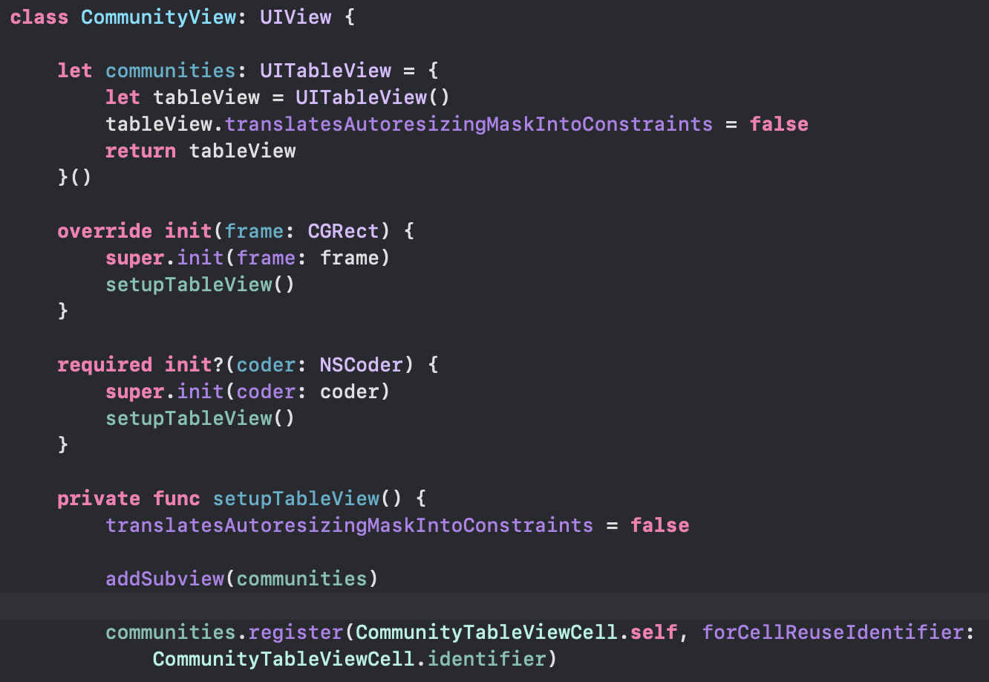

Appendix 3: Code snippet from CommunityViewController: Connection between View and Controller

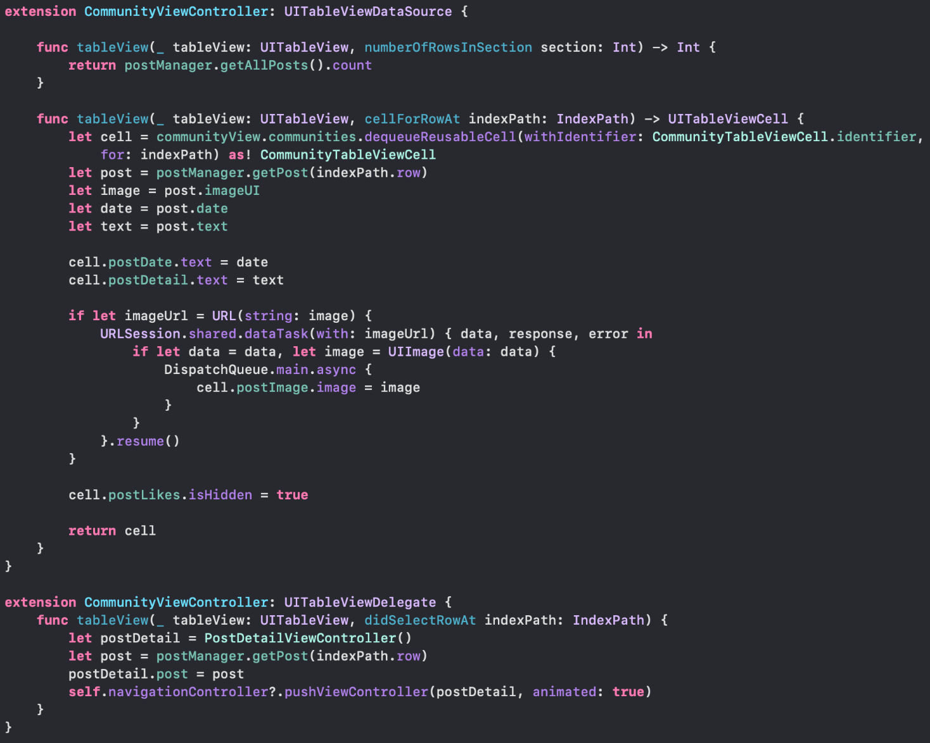

Appendix 4: Code snippet from UserView & UserViewController: How to control UICollectionView

UserView

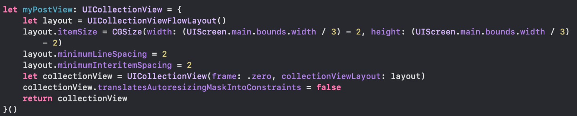

UserViewController: Delegate and Data of UICollectionView

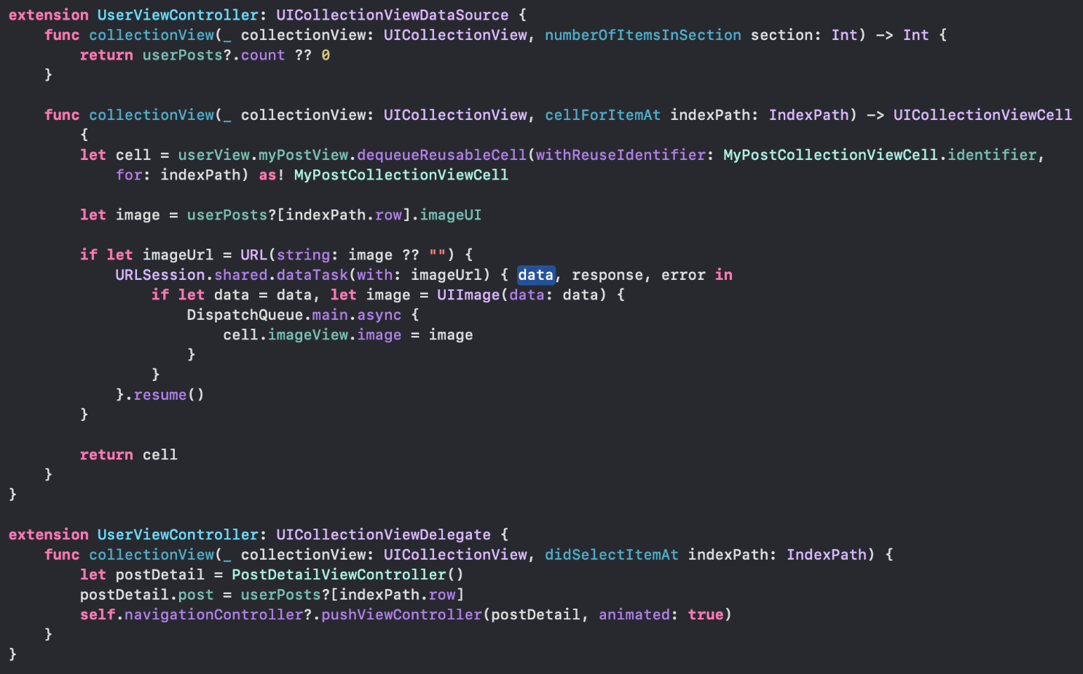

Appendix 5: Code snippet from NewPostView & NewPostViewController: How to control UIPickerView

NewPostView

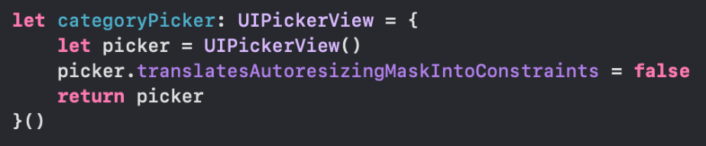

NewPostViewController

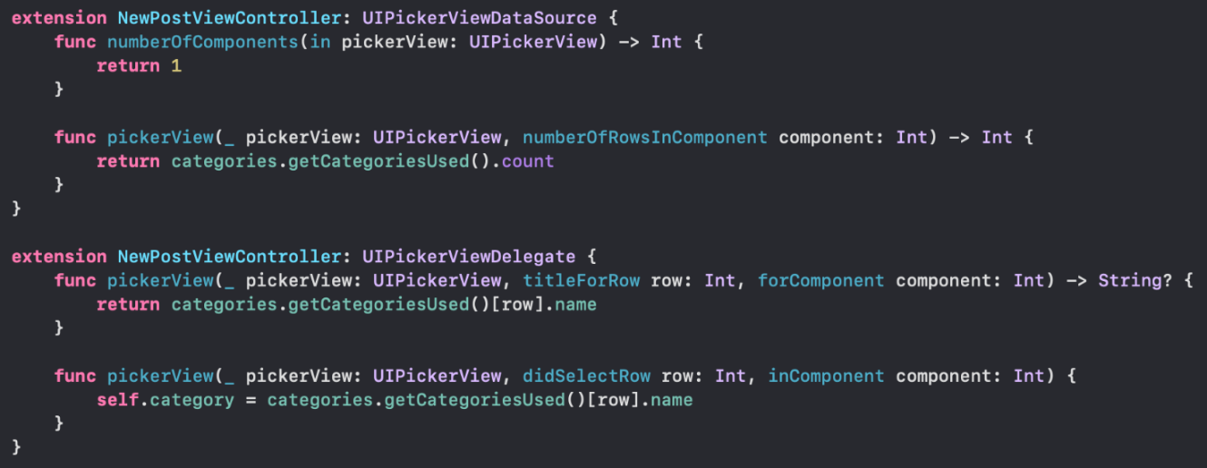

Appendix 6: Code snippet from HomeViewController: Functions for setting the UI of HomeView

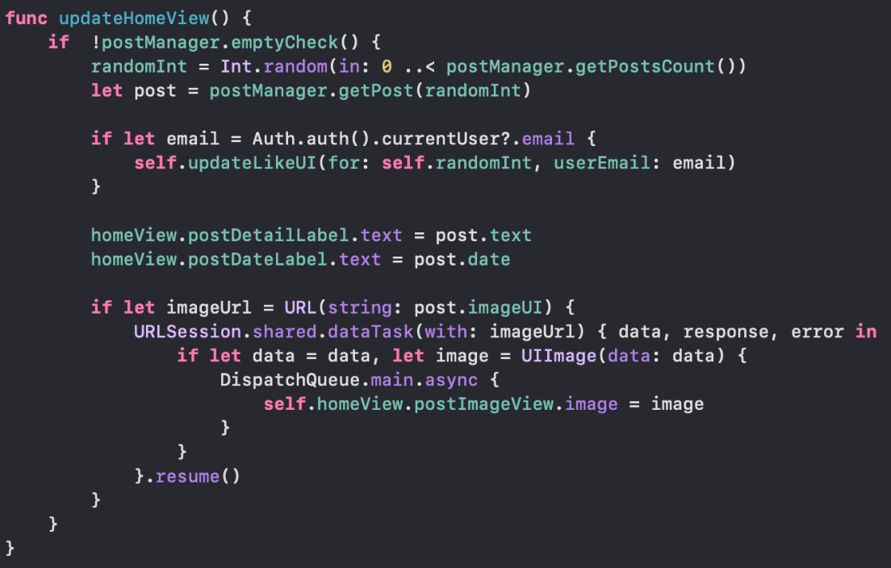

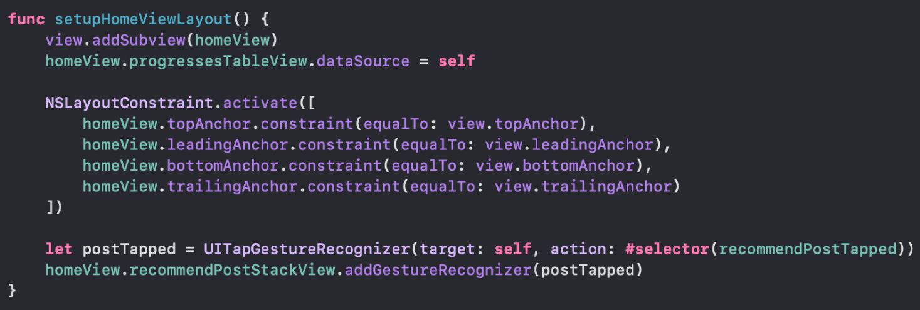

Appendix 7: Code snippet from LoginViewController, SettingViewController, RegisterViewController: Detail about how to control user account

LoginViewController

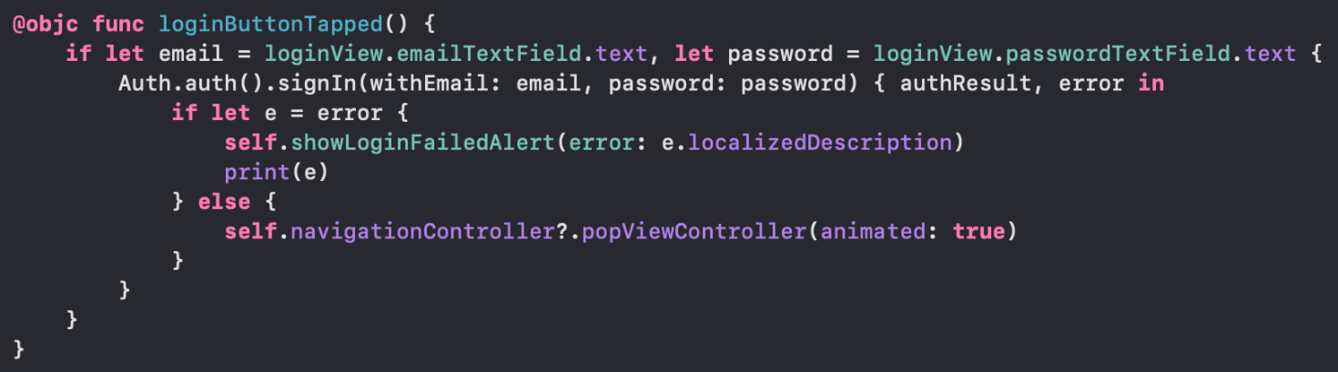

SettingViewController

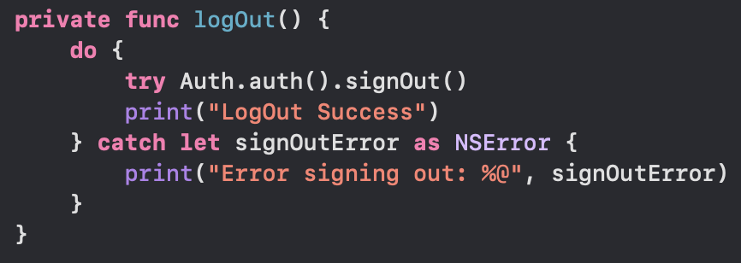

RegisterViewController

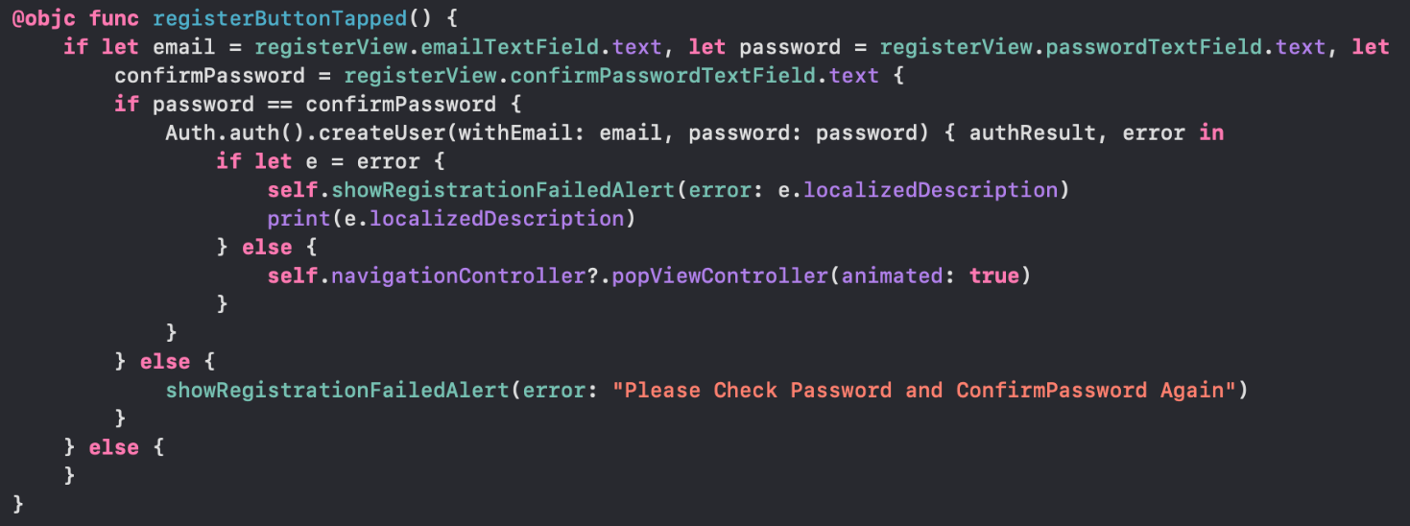

Appendix 8: Code snippet from Database

Database

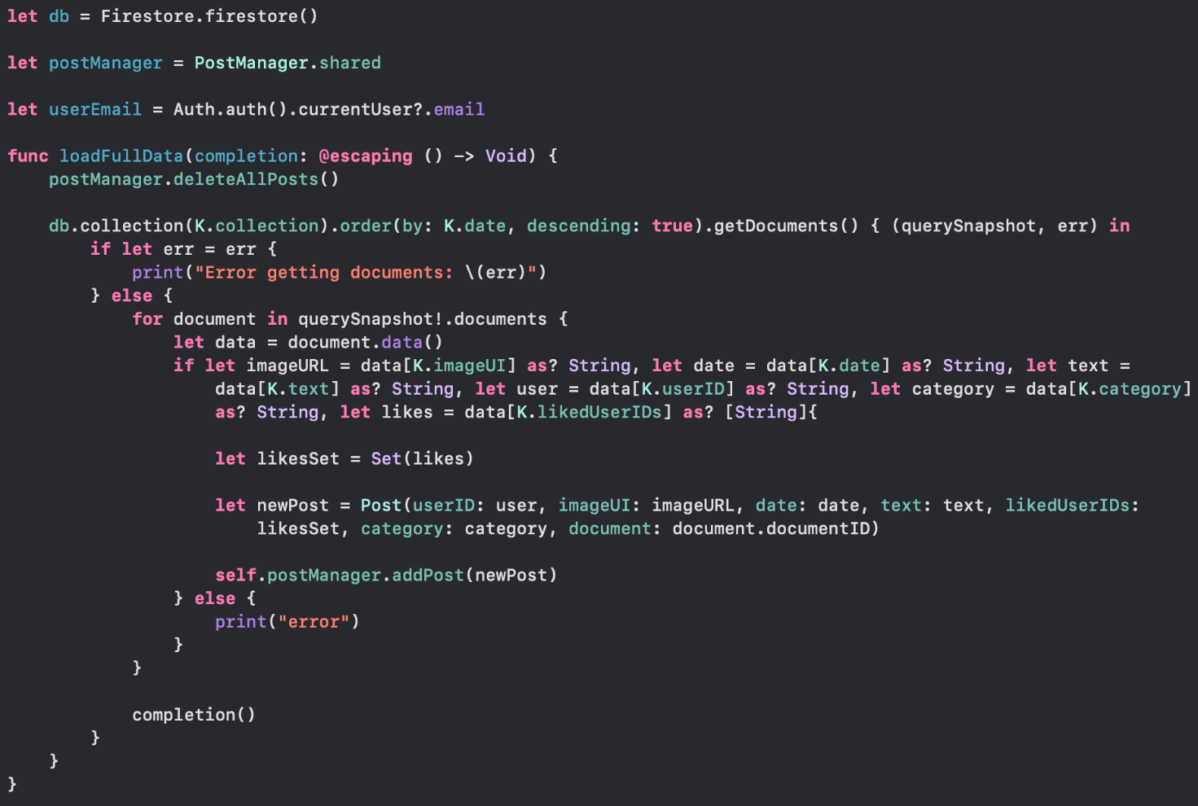

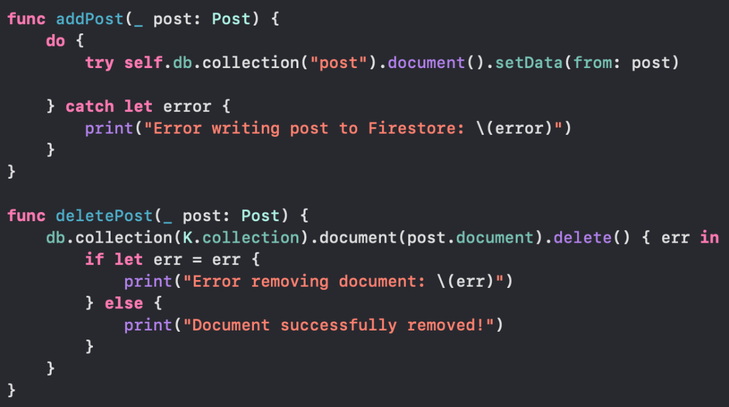

Appendix 9: Code snippet from NewPostViewController, HomeViewController: Actions between Database and Controller

NewPostViewController

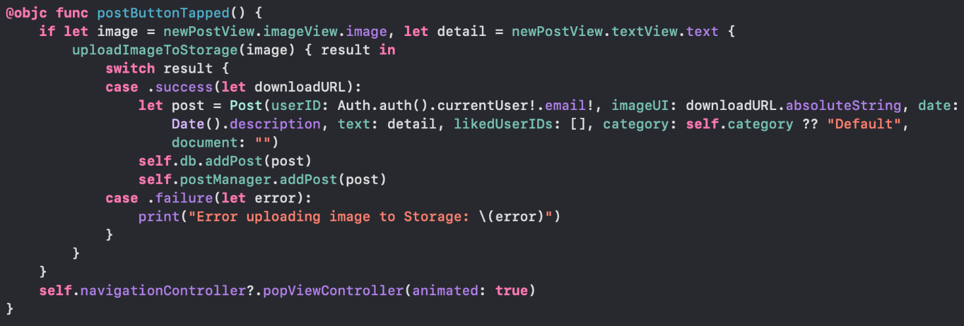

HomeViewController

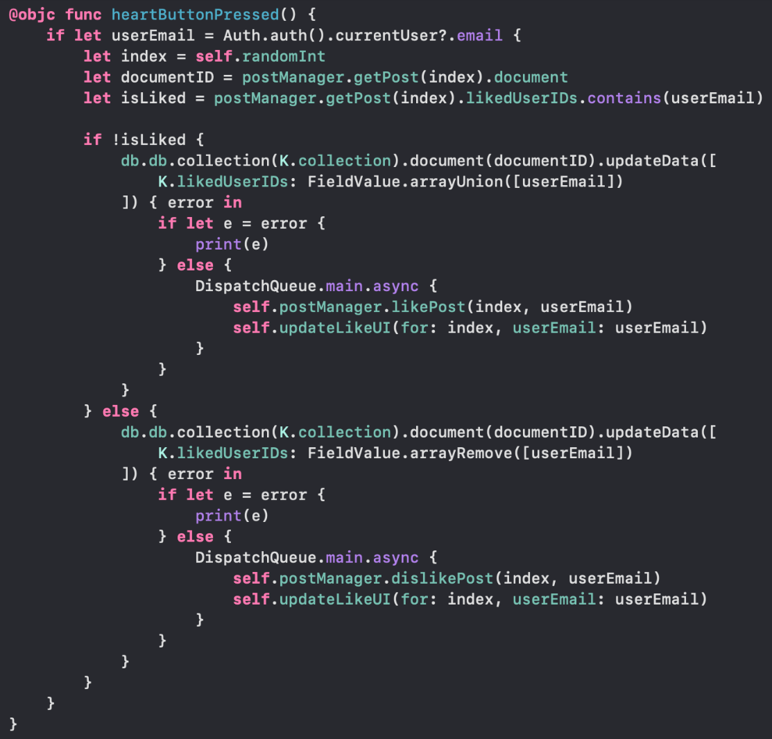

Appendix 10: Code snippet from NewPostViewController, PhotoResultViewController: How to save a image from user and image of feedback

NewPostViewController

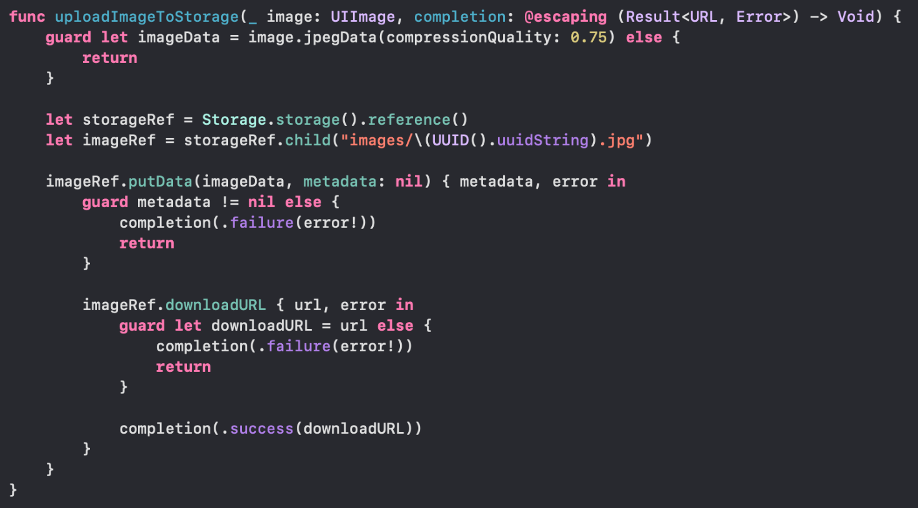

PhotoResultViewController

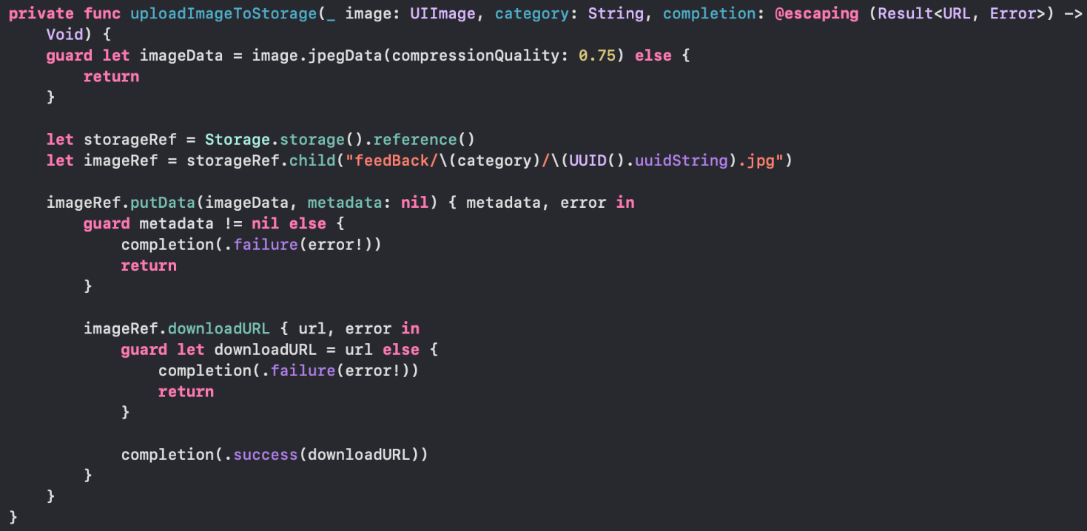

Appendix 11: Code snippet from ModelHandler, PhotoResultViewController

ModelHandler

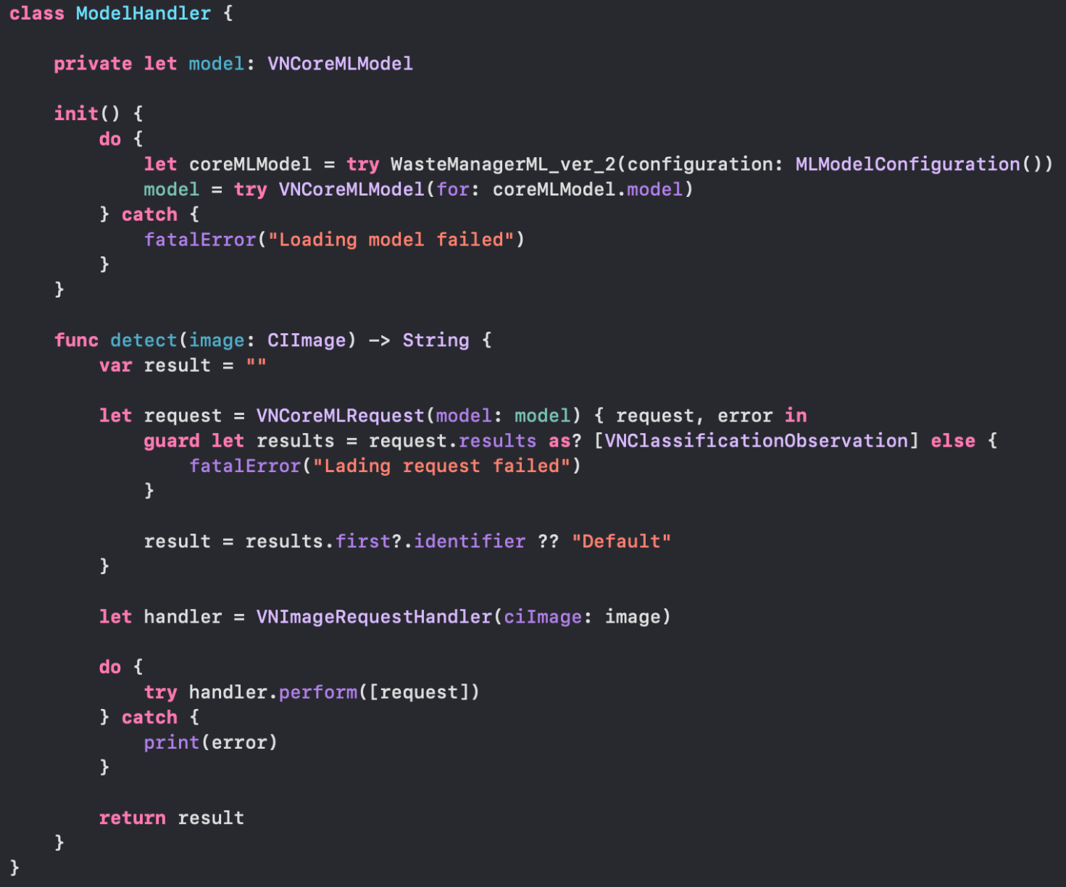

PhotoResultViewController

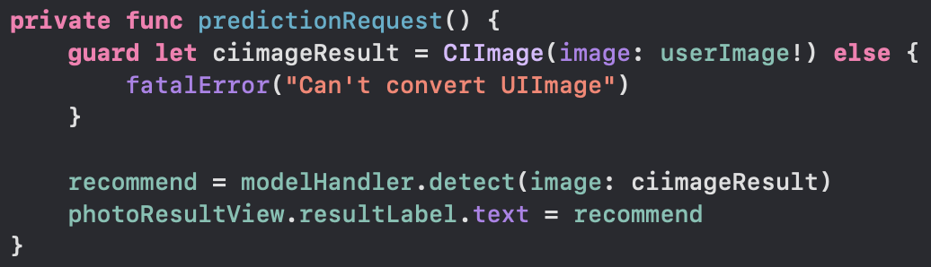

Appendix 12: Code snippet from OpenAIService, CameraViewController: Process of how to get an answer from OpenAI

OpenAIService

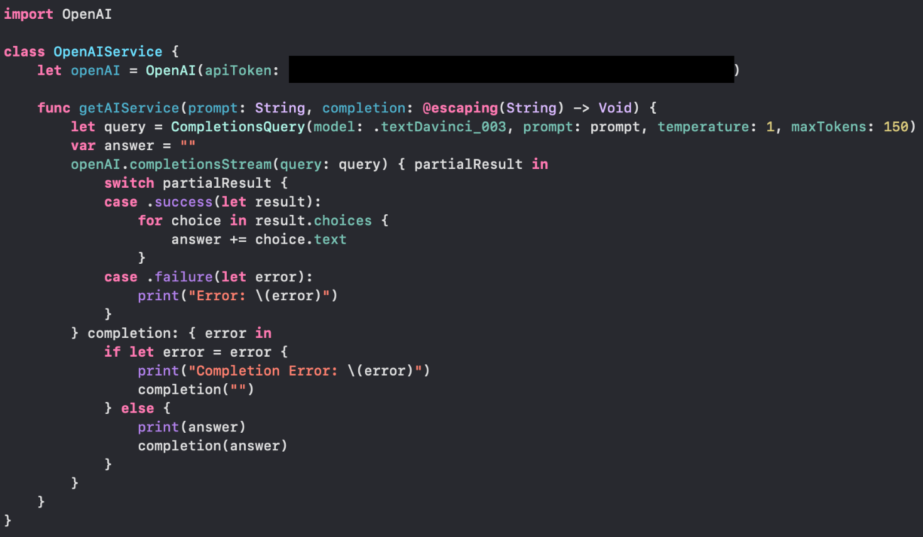

CameraViewController

